**MINISTRY OF EDUCATION AND SCIENCE OF THE RUSSIAN FEDERATION**

**State autonomous educational institution of higher education**

**«National Research Lobachevsky State University of Nizhny Novgorod»**

**Institute of Economics and Entrepreneurship**

**Master’s Degree Studies in Management**

**Analysis of Investment Portfolio Based on Digital Currencies**

**Prepared by**: **Andrés Fernando Regalado Bucheli**

**Supervised by**: **Associate Professor**

**Lyudmila Efimova Ph.D**

Nizhny Novgorod

2019

Contents

**Introduction** 3

**Chapter 1. Understanding digital currency and digital currency investment** 8

**1.1** **Theoretical basis and characteristics of the cryptocurrencies** 8

**1.2** **Investment Portfolio based on digital currencies and investment analysis tools (Fundamental and Technical analysis)** 19

**1.3** **Indexes for technical analysis of digital currency investments** 32

**Chapter 2 Analysis of digital currency investment portfolio** 38

**2.1 Digital currency dynamics** 38

**2.2** **Fundamental and Technical Analysis of cryptocurrencies** 42

**2.3** **Use of indexes, applied to the technical analysis of digital currencies** 57

**Chapter 3 Final portfolio design and analysis of the evolution of the investment at the end of May 2019** 70

**3.1 Comparison of the results obtained according to fundamental and technical analysis** 70

**3.2** **Selection of the final portfolio** 73

**3.3** **Conclusions** 76

**Appendix B Ranking and trends of USD Coin and TrueUSD by Market Capitalization** 94

**Appendix C Information of Digital Currencies and Tokens used in the project** 96

**Appendix D List of resources used for Stage 3 of Fundamental Analysis** 99

**Appendix E Preliminary Portfolios (According to Fundamental Analysis)** 100

**Appendix F Candlesticks Charts** 105

**Appendix G Preliminary Portfolios (According to Technical Analysis)** 110

**Bibliography** 115

# 

# **Introduction**

**Research issue importance.** The emergence of digital money is a manifestation of the digital revolution in the financial and monetary systems. Digital money is defined as any means of payment that only exists in electronic form, and that can only be accounted for, and transferred to make purchases and transactions, using computers (desktops, servers, laptops and mobile devices). Digital money, however, can be converted into cash, using special types of ATMS, and can be used to perform different types of purchases[1].

The impossibility of issuing digital money without prior verification of a blockchain system (this feature greatly differentiates digital money from fiat money, which can be issued by central banks without any control, leading to inflationary phenomena, corruption and social injustice[2]), and the idea of ​​generating large revenues in the future, have attracted the attention of investors, and the inclusion of digital currency in an investment portfolio, becomes more important for them every day[3].

**Purpose.** To build an investment portfolio based on digital currencies, using advanced portfolio management tools, such as fundamental analysis, risk forecasting and technical analysis[4], to analyze the information about the cryptocurrency market available online, and to verify the hypothesis of the convenience of investing in cryptocurrencies during the year 2019. The outcome of the analysis is a diversified investment portfolio, which shows the best investment options (reasonable returns and lowest possible risk), considering the special characteristics of this type of currencies.

**Tasks**

1. Definition of the investment budget that a small investor should allocate to the construction of the portfolio, definition of financial goal and expectations.
2. Collecting, review and comparison with the selection criteria of financial information available on online platforms, corresponding to the most important digital currencies and crypto tokens with the aim of selecting the set of digital currencies that will be included to build the investment portfolio.
3. Application of fundamental analysis techniques to the set of selected cryptocurrencies, in order to determine in a preliminary way, the percentage of the portfolio that the investor should allocate to each cryptocurrency class. (The result of this stage is the creation of three possible preliminary portfolios, based on the knowledge provided by fundamental analysis).
4. Application of technical analysis techniques to the set of selected cryptocurrencies, in order to determine in a preliminary way, the percentage of the portfolio that the investor should allocate to each cryptocurrency class. (The result of this stage is the creation of three possible preliminary portfolios, based on the knowledge provided by technical analysis).
5. Weighing the results of the technical analysis and the fundamental analysis to calculate the percentages that will be granted to each digital currency, within the portfolio. (The result of this stage is the creation of the final portfolio).

**Main items for defense (First stage)**

1. Document with the investment plan (Budget, financial goal, expectations of return), comparative tables and a checklist where the set of selected digital currencies is shown.
2. Comparative table where financial information corresponding to the selected digital currencies is shown, and tabulation of data where the convenience of investing in each of them is demonstrated, according to the theory of the fundamental analysis.
3. Creation of three preliminary investment portfolios, using fundamental analysis.

**Main items for defense (Second Stage)**

1. Demonstration of statistical results, analysis of charts, graphs, and historical data. Comparative tables that show the advantages and disadvantages of investing in each one of the selected digital currencies and risk forecasting, using technical analysis.
2. Creation of three preliminary investment portfolios, using technical analysis.
3. Creation of the final portfolio.

**Research object.** The object of study is the market for cryptocurrencies, paying special attention to the ten digital currencies that lead the market at the end of 2018. (Bitcoin, Ethereum, XRP, Bitcoin Cash, EOS, Stellar, Litecoin, Cardano, Tether, Monero), and paying attention too, to crypto tokens with high appreciation in the capital market of cryptocurrencies or with high level of reliability related to the projects associated with them.

**Research subject.** The subject of study is to carry out an investment analysis, using Fundamental analysis and Technical analysis, on the cryptocurrencies Bitcoin, Ethereum, XRP, Bitcoin Cash, EOS, and on the crypto Tokens TrueUSD and USD Coin, with the objective of including these digital currencies and crypto Tokens, in a diversified portfolio of investments based on cryptocurrency.

**Research hypothesis.** Despite the fall in the price of Bitcoin at the end of 2018[5], it is possible to consider that due to the characteristics of Bitcoin (Bitcoin is backed up by a computer network that is virtually impossible to attack), and due to the global economic and geopolitical situation, the price of Bitcoin will rise again during 2019 and that it is worth to invest in Bitcoin to store capital or to trade it to make a profit. The digital currency linked to the Ripple project, known as (XRP), has shown relative stability in the market during the year 2018, (despite the general fall in the price of most digital currencies, which occurred at the end of 2018), ranking second in the capitalization market since November 2018 until March 2019 and temporarily displacing Ethereum, which kept in that position for most of the year 2018. (See Appendix A).

According to the figures published in the different online platforms that offer information in real time on the evolution of digital currency prices, and considering factors such as technological development, possibilities, long-term prospects of the Ripple project, sources of investment and market capitalization, it is possible to formulate the hypothesis that investment in XRP, allows the investors to store value, while the price manages to stabilize[6] and that it is worth to include this currency, within the investment portfolio. Another great advantage of investing in this digital currency is its low price, compared to digital currencies like Bitcoin that reach a unit price of more than 3800 dollars, at the beginning of the year 2019. (See Appendix A).

EOS, has remained in the top 5, since April 2018 and due to its low price and its stability, it is considered that it is worth diversifying the portfolio investing on this cryptocurrency. (See Appendix A).

According to the information that appears in specialized publications, the digital currencies True USD, and USD Coin will be consolidated as a good alternative to invest in Tokens, during 2019 and it is considered that including them in the investment portfolio is worth. (See Appendix B). However, this type of coins, known as Stable Coins, are conceptually separated from the philosophy that lead to the creation of cryptocurrencies and it is considered that Ethereum could be a better investment alternative. (Fundamental Analysis will be used to include or discard this option within the portfolio).

**Methods of research**

**Subjects of concern**

Bitcoin,Ethereum, XRP, Bitcoin Cash, EOS, TrueUSD,USD Coin.

**Theoretical approach from the scientific point of view**

The conclusions about the characteristics and behavior of the different digital currencies analyzed are obtained using a combination of the inductive-qualitative (fundamental analysis) and deductive-quantitative (technical analysis) approaches.

**Research strategy**

Quantitative (Technical Analysis).

Qualitative (Fundamental Analysis).

**Theoretical base.** Advanced Portfolio Management Theory - Fundamental and Technical Analysis, Blockchain for Business Theory, Blockchain uses and implications, Bitcoin and Cryptocurrencies. (See list of references for complete information).

**Information base**

**Population.** Historical prize data of the digital currencies belonging to the set of the most profitable digital currencies and Tokens available in the market, that represent the most promising prospects to make profits. Financial information about companies.

**Sample.** Historical prize data of Bitcoin, Ethereum, XRP, Bitcoin cash, EOS, TrueUSD, and USD Coin, that show the evolution of the prizes and the trends during 2018 and the beginning of 2019.

**Sources of quantitative data**

**Secondary data.** Statistics obtained from the online platforms dedicated to offer information about the evolution of the prices of digital currencies such as:

[www.coinmarketcap.com](http://www.coinmarketcap.com), [www.conintracking.info](http://www.conintracking.info), [www.coincheckup.com](http://www.coincheckup.com), [www.blockchain.com](http://www.blockchain.com), [www.bitcoincharts.com](http://www.bitcoincharts.com).

**Case of study.** Bitcoin, Ethereum, XRP (Ripple), Bitcoin cash, EOS, TrueUSD, USD Coin.

**Research designs**

**Cross sectional.** Study and comparison of the mainstream digital currencies, using Advanced Portfolio Management tools (Fundamental and Technical Analysis), conducive to find patterns of association between the different currencies and conducive to choose the best options to diversify the investment portfolio.

**Case study design.** Study of the possible evolution and the risk/return tradeoff involved in investing in Bitcoin, XRP (Ripple), EOS, TrueUSD and USD Coin, during the beginning of the year 2019.

# **Chapter 1. Understanding digital currency and digital currency investment**

## **Theoretical basis and characteristics of the cryptocurrencies**

**1.1.1 Definition of Blockchain technology, cryptocurrency, altcoins, Initial Currency Offerings, crypto tokens, and digital currency investment**

**Blockchain technology.** Blockchain technology is the technology that supports digital currencies. Front the point of view of design, Blockchain is resistant to the modification of the data. It is an open and distributed ledger that can record transactions between two parties efficiently in a verifiable and permanent way[7], and it was invented by Satoshi Nakamoto in 2008 to be used as the public transaction ledger of the cryptocurrency known as Bitcoin[8].

Blockchain builds a chronological chain of blocks, hence the name "block-chain". A block refers to a set of transactions that are bundled together and added to the chain at the same time.

Combined with cryptographic hashes, this timestamped chain of blocks provides an immutable record of all transactions in the network, from the very first (or genesis) block.

In the Bitcoin network, miners must solve a cryptographic challenge to propose the next block. This process is known as "proof of work" and requires significant computing power.

The record of an event, cryptographically secured with a digital signature, that is verified, ordered, and bundled together into blocks, form the *transactions* in the blockchain. In the Bitcoin blockchain, transactions involve the transfer of bitcoins. Furthermore, a smart contract within the blockchain may allow automatic execution of transactions upon meeting predefined criteria[9].

The immutability of the data which sits on the blockchain system is perhaps the most powerful and convincing reason to deploy blockchain-based solutions for a variety of socio-economic processes which are currently recorded on centralized servers [10]. Experts in technology believe that Blockchain will become a technology as revolutionary as the Internet was twenty years ago [11].

**Cryptocurrency.** The roots of digital currencies are linked to the revolutionary ideas promoted by two movements that appeared in the late eighties in the realm of computer science experts. The names of these two movements are Cypherpunk[12] and Crypto-anarchism[13]. These movements emerged with the purpose of promoting the widespread use of strong cryptography and cryptographic software in order to evade harassment and persecution while sending and receiving information over computer networks and digital systems, and with the aim of protecting privacy, protecting economic and political freedom, and evading control of central governments. The origins of digital currencies are related too, to the concept of Libertarianism[14], which is a political ideology that promotes the minimum intervention of a centralized authority. Another fundamental reason that lead to the creation of digital currency, was to find a solution to the problem of double spending of money and fraud, which increasingly affects banking institutions due to the implementation of digital solutions. Therefore, it was necessary to create an anonymous digital “transaction system” or currency, that could protect the users from government intervention and could allow them to perform transactions without the intervention of third parties, and without the risk of becoming victims of fraud.

A cryptocurrency is a type of digital asset stored in a blockchain that it is supported by cryptography (practice of techniques for information security). Cryptocurrencies are used as a medium of exchange, but unlike traditional currencies, that were backed up by gold and silver until 1971 and which now are only supported by government agreements (Fiat money), cryptocurrencies are backed up by cryptographic algorithms and by a powerful computer network.

The most famous digital currency is Bitcoin and it was conceived in 2008 by Satoshi Nakamoto[15], and the protocol to create it, including the use of blockchain technology, was derived from the need to solve the problem of double spending of money, which had been affecting banking institutions for a long time.

In 2011[16], another series of new digital coins know as altcoins appeared, and these digital currencies are based on changes in programming created by the developers. Among the most important altcoins it is possible to find Ethereum, XRP, Bitcoin Cash and Litecoin[1].

**Altcoins.** Altcoins are the various alternative cryptocurrencies that were launched after the massive success achieved by Bitcoin. Literally, the term means alternative coins - that is – other than bitcoins. They were launched as enhanced substitutes of Bitcoin with the claims to overcome some or the other pain points of Bitcoin. [Litecoin](https://www.investopedia.com/terms/l/litecoin.asp), [Bitcoin Cash](https://www.investopedia.com/terms/b/bitcoin-cash.asp), [Namecoin](https://www.investopedia.com/terms/n/namecoin.asp), are examples of altcoins. Though each has tasted varying levels of success, none of them have managed to gain popularity akin to Bitcoin. Bitcoin is considered the Gold standard in the cryptocurrency world.

Terms like [cryptocurrency](https://www.investopedia.com/terms/c/cryptocurrency.asp), [altcoins](https://www.investopedia.com/terms/a/altcoin.asp), and crypto tokens are often erroneously used interchangeably in the virtual currency market.

Technically, they are all different terms. Cryptocurrency is the superset, and altcoins and crypto tokens are its two subset categories. Initial Currency Offerings are sold in the form of Tokens.

A cryptocurrency is a standard currency which is used for the sole purpose of making or receiving payments on the blockchain which doesn’t mean that it can not be used for trading or purchasing. For instance, the most popular cryptocurrency is [Bitcoin](https://www.investopedia.com/terms/b/bitcoin.asp)[17].

**Initial Currency Offerings.** An Initial Currency Offering (ICO) is the cryptocurrency space's rough equivalent to an IPO (Initial Public Offering) in the mainstream investment world. ICOs act as fundraisers of sorts; a company looking to create a new coin, app, or service launches an ICO. Next, interested investors buy in to the offering, either with fiat currency or with preexisting digital tokens like Bitcoin or Ether. In exchange for their support, investors receive a new cryptocurrency token specific to the ICO. Investors hope that the token will perform exceptionally well into the future, providing them with a stellar return on investment. The company holding the ICO uses the investor funds as a means of furthering its goals, launching its product, or starting its digital currency. ICOs are used by startups to bypass the rigorous and regulated capital-raising process required by venture capitalists or banks[18].

However, the investment in ICOs is highly risky, because many of the projects linked to these currency offers published on the different platforms, fade away before reaching the desired budget or due to the large number of fraudulent projects existing in the network, which are being used to raise money illegally.

When a [cryptocurrency](https://www.investopedia.com/terms/c/cryptocurrency.asp) startup firm wants to raise money through an Initial Coin Offering (ICO), it usually creates a plan on a whitepaper which states what the project is about, what need(s) the project will fulfill upon completion, how much money is needed to undertake the venture, how much of the virtual tokens the pioneers of the project will keep for themselves, what type of money is accepted, and how long the ICO campaign will run for. (A white paper is an authoritative report that informs readers about a complex issue. It is meant to help readers understand an issue, to make a decision or solve a problem). During the ICO campaign, enthusiasts and supporters of the firm’s initiative buy some of the distributed crypto coins with [fiat](https://www.investopedia.com/terms/f/fiatmoney.asp) or virtual currency (generally Bitcoin or Ethereum).

ICOs are different from equity. Having a new project´s coin doesn’t give a holder, ownership of the project, but instead enables him to use the project when it becomes available and this is a revolutionary practice of crowdfunding (practice of funding a project by raising very small amounts of money from a large number of people)[19].

Most web platforms that offer information about ICOs, divide these Tokens into three main categories. Coming status (Token has not started yet, thought its future date is already determined), Running status (The Token has been started), Over status (the Token has ended).

**Crypto Tokens.** Tokens or Crypto tokens, represent a particular fungible and tradable asset or a utility that is often found on a blockchain.

Crypto tokens are special kind of virtual currency tokens that reside on their own blockchains and represent an asset or utility. For example, one can have a crypto token that represents x number of customer loyalty points on a blockchain that is used to manage such details for a retail chain. There can be another crypto token that gives entitlement to the token holder to view 20 hours of streaming content on a video-sharing blockchain. Another crypto token that may even represent other cryptocurrency, like one such token being equal to 15 bitcoins on a particular blockchain. Such crypto tokens are tradable and transferrable among the various participants of the blockchain.

Such crypto tokens often serve as the transaction units on the blockchains that are created using the standard templates like that of Ethereum network that allows a user to create his/her own tokens. Such blockchains work on the concept of [smart contracts](https://www.investopedia.com/terms/s/smart-contracts.asp) or [decentralized applications](https://www.investopedia.com/terms/d/decentralized-applications-dapps.asp), where the programmable, self-executing code is used to process and manage the various transactions occurring on the blockchain.

In essence, the cryptocurrencies and altcoins are specific digital currencies that have their own dedicated blockchains and are primarily used as a medium for digital payments. On the other hand, the crypto tokens operate on top of a blockchain that acts as a medium for creation and execution of decentralized apps and smart contracts, and the tokens are used to facilitate the transactions.

Such crypto tokens are usually created, distributed, sold and circulated through the standard [initial coin offering (ICO)](https://www.investopedia.com/terms/i/initial-coin-offering-ico.asp) process that involves a crowdfunding exercise to fund project development[20].

**Digital Currency Investment.** Forex and cryptocurrency markets are influenced by the laws of supply and demand. The cryptocurrency market is structured to work identically like stock market trading with stop-loss protections, extreme price swings, volatility and profit objective orders that comes with currency speculation in the Forex[10, p.46].

One of the biggest differences between Forex and cryptocurrency market is that most cryptocurrencies have a limited supply, and another difference is the size of the market. The value of a digital currency is heavily influenced by the eco-system of cryptocurrencies, while the Forex is influenced by the economics of the individual countries that are being traded. Another big difference is that cryptocurrency can be traded all day, every day while the Forex is only open all day for five days.

There are different ways to start investing in digital currency. It is possible to invest in Bitcoin, in Altcoins, in Initial Currency Offerings or in Tokens.

The procedure to start investing in digital currencies is not complicated. The investor, only needs to make use of any of the existing online platforms that are dedicated to the sale or trading of digital currencies (known as exchanges), to create a crypto-wallet (digital wallet) and to know the laws of the country where the investor is located, (the use of digital currency in some countries of the world is totally prohibited by law, Algeria, Bangladesh, Bolivia, Egypt)[21].

Cryptocurrency markets are very volatile. The market is prone to bubbles that can come and go very quickly. For that reason, it is necessary to use Fundamental Analysis and Technical Analysis in order to take wise decisions when it comes time to diversify the portfolio. It is not recommended at all, to buy at the peak of a bubble and the best time to buy is when the price is stable and at a lower level. As a rule of investment in cryptocurrency, investors should never compare cryptocurrency bubbles with Forex bubbles because of volatility. A small percentage may mean a bubble in the Forex, but that is considered just as daily volatility in the cryptocurrency market.

Just like the Forex, the cryptocurrency market will show trends and patterns and technical analysis techniques are very useful to help the investors to decide when to buy and sell.

Before making the investment, it is necessary to consider several factors[22].

* The investor must to decide which kind of cryptocurrency he or she is interested in.
* The investor must to decide what type of investment he or she is after (short-term or medium to long-term endeavors).
* Do not forget to review the statistics constantly.
* The investor must to find out whether the digital asset is widely accepted and trustworthy.
* It is recommended to take a look at the major crypto players too.
* To invest the right amount of money is recommended.

**1.1.2 Theoretical criteria to select cryptocurrencies, altcoins, crypto tokens, and Initial Currency Offerings to invest**

**Rating Digital Coins, Tokens and Initial Currency Offerings.** It is recommended that investors, when starting the market researching, use certain theoretical criteria, which allow them to gather important information about potential digital currencies that capture their attention. These criteria that should be taken into consideration, are listed below[10, p.61].

**Avoid the Pump and Dump.** Pump and Dump is a scam strategy that is illegal in any market. Nevertheless, cryptocurrency market is especially vulnerable to this scam because it is hard to control a decentralized network. The scammers buy a large amount of a cheaper coin over a period, promoting it. The victims buy this coin believing that an upward trend is developing. Trading volume increases and the value of that coin goes up. Once the coin reaches the point the scammers desire, they sell all their coins. Everyone else who sees this, often panics and begins to sell, sending the coin crashing downwards. Often everyone else but the scammers lose.

**Research of the Whitepaper.** Instead of a traditional business plan or formal prospectus, in the realm of crypto currencies and crypto coins, white papers are used. A well written whitepaper must to show to the investors a good deal of the information they need to know before investing. The basic important information that should be covered in the whitepaper is how the platform will work, the potential uses, the coin pricing structure and the development plan the coin proceeds)[10, p.59].

**Research of the Website.** Every ICO, Token or cryptocurrency must have an official online presence. The best selection criteria it is to find out if a coin or ICO website/landing page easily provides the investors with a good deal of information to answer the important questions in a straightforward manner. They must to provide access to their whitepaper and could have other useful links to supporting information in order to be considered reliable[10, p.60].

**Research of Social Media, Discussion Boards and News.** The cryptocurrency market and ICOs are a very popular everyday topic. A crypto investor should be able to easily find information, people’s opinions, expert reviews, etc. on a variety of different channels. The more active a digital coin is on social media, promoting and keeping the public aware of its developments, the better it is for investor confidence and research potential[10, p.60].

**Research Rating Websites.** Coin rating websites are a very good resource to be able to compare different coins, to read news about them, to become aware of alerts and cautions and to select coins to participate in[10, p.60].

**Recommended rating Checklist.** Below, there is a list of important selection criteria, that should be taken into consideration before deciding to invest in a specific digital currency[10, p.61].

* Objective of the coin (Token or ICO).
* Solution of a problem or strong usage (The greater the impact of the problem the coin solves, the better value the coin will have).
* Structure of the whitepaper (Supporting by experts, opinions, explanation of the technology in depth).
* Backing up of the project (The coin will appear to be more credible if it is backed up by prominent investors).
* Centralization or decentralization (Cryptocurrencies are meant to be decentralized in nature, however there are some of them that are centralized and have their own advantages).
* Development plan (Clear timeline for the development of the coin).
* Money raised and money spent (Financial info on spending habits show a great deal about the team behind the coin).
* Differentiation from the nearest competitor.
* Strength of the target market (Small niche groups won’t be strong. The group needs to be large enough to support growth but still well defined).
* Legal barriers (To make sure that there are not issues with the chosen coins).
* Founding team members (The success of a coin depends largely on the core founding team).
* Active communication.
* Amount of coins in the future (Finite supply makes a coin have a stronger value).
* Amount of coins given to the founding team (The higher the percent of coins given to the founding team, the worst. They can manipulate the market price).
* Market capitalization.

**1.1.3 Characteristics of the digital currencies and the Initial Coin Offerings selected for investment analysis**

**Bitcoin.** Bitcoin is the first decentralized ledger currency, founded in 2009. It was initially created to facilitate easier global transactionswith low transaction fees that can be transferred almost instantlyand were not controlled by any central financial authority.

Today, Bitcoin has become the most popular cryptocurrency with the highest market value. Bitcoin is leading the way for more mainstream vendors to adopt this form of currency for everyday type of purchases[10, p.13]. (See Appendix C for financial information). Bitcoin was the inspiration for blockchain technologies.

Bitcoin attempts to solve two problems that decentralized networkstypically face:

* Inconsistent transactions records held by different nodes.
* Malicious pseudonymous actors might broadcast false messages and divide the network.
* Double spending attacks:asynchronous records held by different nodes.
* The blockchain and consensus protocol are the solution[23].

White paper available at: <https://bitcoin.org/bitcoin.pdf>

**Ether.** Ether is the coin used by the Ethereum platform and is very different to Bitcoin and other altcoins. In fact, initially it wasn’t designed to be a currency, it was designed to support smart contracts. The idea was that Ethereum miners would provide companies their processing power so that these companies wouldn’t need to invest in additional servers. In this scenario, Ether is used to be a form of payment on a platform[6, p.14]. (See Appendix C for financial information).

White paper available at: <https://github.com/ethereum/wiki/wiki/White-Paper>

**XRP.** The initial release date for Ripple was in 2012, and it was created for peer to peer debit transfers. It is the third most popular cryptocurrency in terms of market value as of the September 2017.

Bitcoin’s primary purpose is to be a payment method while Ether is meant to be used for smart contracts. Ripple also has a different use. It has become a decentralized solution for financial institutions and acts as both a cryptocurrency and a digital payment network.

This situation developed because a wide range of financial institutions began to take notice that the technology eliminates delays, confirms that a settlement has taken place in real time (about 4 seconds), and can sustain 1000 transactions per seconds while Bitcoin is only averaging 3 to 4[10, p.14]. (See Appendix C for financial information).

White paper available at <https://ripple.com/files/ripple_consensus_whitepaper.pdf>

**Bitcoin cash.** On August 1st, 2017 Bitcoin forked, and created Bitcoin Cash. This fork was started by Bitcoin miners and developers who were concerned about Bitcoins ability to scale. Bitcoin Cash implemented an increased block size as well as other measures to speed up the verification process regardless of the number of miners supporting it. While these changes have raised concerned about security, it has not prevented this cryptocurrency from quickly rising up the market ranks [6, p.15] (See Appendix C for financial information).

White paper available at: <https://github.com/bitcoincashorg/>

**EOS.** EOS.IO is a [blockchain](https://en.wikipedia.org/wiki/Blockchain) protocol powered by the native [cryptocurrency](https://en.wikipedia.org/wiki/Cryptocurrency) EOS. The protocol emulates most of the attributes of a real computer including hardware ([CPU](https://en.wikipedia.org/wiki/Central_processing_unit)(s) & [GPU](https://en.wikipedia.org/wiki/Graphics_processing_unit)(s) for processing, local/[RAM](https://en.wikipedia.org/wiki/Random-access_memory) memory, hard-disk storage) with the computing resources distributed equally among EOS cryptocurrency holders. EOS.IO operates as a [smart contract](https://en.wikipedia.org/wiki/Smart_contract) platform and decentralized operating system intended for the deployment of industrial-scale decentralized applications through a [decentralized autonomous corporation](https://en.wikipedia.org/wiki/Decentralized_autonomous_corporation) model. The smart contract platform claims to eliminate transaction fees and also conduct millions of transactions per second [24]. (See Appendix C for financial information).

White paper available at: <https://github.com/EOSIO/Documentation/blob/master/TechnicalWhitePaper.md>

**TrueUSD.** TrueUSD provides its token holders regular attestations of escrowed balances, full collateral, and also the legal protection against misappropriating underlying USD.

The team believes that TrueUSD will be able to come up with the stable trading instrument for the traders of cryptocurrency that has been long-awaited. This will allow the businesses and consumers to use the digital currency as a medium of an exchange.

The goal of the TrueUSD team was to build a coin that is stable and which can be used and trusted by them too. TrustToken is a platform that creates the tokens backed by assets that can easily be purchased and sold all around the world.

The first asset token of TrustToken is TrueUSD, which is a stable coin and can be redeemed 1-for-1 for US dollars[25]. (See Appendix C for financial information).

**S**ource code available at: <https://github.com/trusttoken>

**USD Coin.** Circle co-founders Sean Neville and Jeremy Allaire wrote in a blog post Wednesday that its USD Coin (USDC), developed with help from the company’s CENTRE affiliate consortium, would act as a mean to tokenize U.S. dollars to easily transfer value on public blockchains.

A fundamental building block of this vision is the tokenization of fiat currency itself, through what are now referred to as fiat Stablecoins. A safe, transparent and trustworthy layer for fiat to operate over open blockchains and within smart contracts is a necessary precondition to the broader and more revolutionary potential of a crypto-powered global economy[26]. (See Appendix C for financial information).

Source code available at: <https://github.com/centrehq/centre-tokens>

## **Investment Portfolio based on digital currencies and investment analysis tools (Fundamental and Technical analysis)**

**1.2.1 Definition of investment portfolio based on digital currency**

An investment portfolio based on digital currency or cryptocurrencies, is basically a combination of financial assets which is entirely made up of investments in digital money and it follows the same principles of investor’s risk tolerance, investment time horizon, financial goal and expected return that rules the management of other kind of investment portfolios.

The investment rules, investment strategies, and the advanced portfolio management theory are applicable to an investment portfolio based on digital currencies. This means that the general principles of maximizing the expected return and minimizing the risk, are applicable[27], and the key concepts such as asset allocation and diversification, are applicable too.

According to the classic theory of advanced portfolio management, the keys to successful investing can be identified by a few simple concepts[27]:

* Proper diversification with uncorrelated investments.
* A structured index-based approach to build a proper portfolio.

**1.2.2 Theoretical explanation about technical and fundamental analysis in advanced portfolio management**

Portfolio management is the art and science of making decisions about investment mix and policy, matching investments to objectives, asset allocation for individuals and institutions, and balancing risk against performance. Portfolio management is all about determining strengths, weaknesses, opportunities and threats in the choice of debt vs. equity, domestic vs. international, growth vs. safety, and many other trade-offs encountered in the attempt to maximize return at a given appetite for risk[27].

Advanced Portfolio Management is a field of study that is closely connected with the problem of capital asset pricing. The essence of this correlation is explained below:

If a capital holder N at the moment *t=0*, whose total wealth is . The capital holder is aware that if he (or she) invests his savings in some capital assets, he (or she) runs the risk. What are the reasons of this investment risk?

The main types of securities are bonds, shares, derivatives. Investors may use foreign-exchange holdings, commodities (such as gold) and, at last, real estate holdings but to Invest in cryptocurrency, investors can use online platforms. Prices of all of these assets are formed under conditions of market trading. The cryptocurrency market works on a similar way. Market demand, and supply, vary in time in a random way, so market price fluctuates chaotically. If the investor will tend to sell some asset in the future, his income becomes uncertain. Thus, return on investment will be uncertain also.

Portfolio analysis usually applies *return on the investment* as an indicator of investment results

; (1)

more exact definition of return is

 (2)

Definition (1) is the first-order approximation of the relation (2).

Uncertainty of future investor’s result is considered risk in the theory of advanced portfolio management.

When capital holder decides what assets should be included in the investment portfolio, the investor forms his individual demand for particular assets. This demand depends on the price of each asset.

The relation between individual portfolio selection and the demand for capital assets is the key pillar of asset pricing theory.

In the case that there is an ensemble of capital holders; if it is possible to sum a set of individual demand functions for any asset, it is possible to obtain aggregated demand for it (this is called “market demand”). What will be happen when market demand exceeds the total amount of asset? Evidently, asset price will tend to increase. On the contrary, if investors don’t want to hold all available amount of asset, asset price will decline. As a result, it is possible to derive two substantial conclusions.

1. The problem of capital asset pricing is considered only in terms of demand. A supply curve is not taken into consideration because there are no costs in the world of securities (if transaction expenses are not taken into consideration). Next asset prices are formed due to decisions in portfolio selection of ensemble of individuals.
2. Market equilibrium exists when aggregated “demand to hold” for each asset is equal to the total amount of the asset. Obviously, asset prices will no tend to change in this case[28].

**Key elements of Portfolio Management.**

**Asset Allocation.** The key to effective portfolio management is the long-term mix of assets. [Asset allocation](https://www.investopedia.com/terms/a/assetallocation.asp) is based on the understanding that different types of assets do not move in concert, and some are more volatile than others. Asset allocation seeks to optimize the risk/return profile of an investor by investing in a mix of assets that have low correlation to each other. Investors with a more aggressive profile can weight their portfolio toward more volatile investments.

Investors with a more conservative profile can weight their portfolio toward more stable investments.

**Diversification.** The only certainty in investing is it is impossible to consistently predict the winners and losers, so the prudent approach is to create a basket of investments that provide broad exposure within an asset class. [Diversification is the spreading of risk](https://www.investopedia.com/terms/d/diversification.asp) and reward within an asset class. Because it is difficult to know which particular subset of an asset class or sector is likely to outperform another, diversification seeks to capture the returns of all of the sectors over time but with less volatility at any one time. [Proper diversification](https://www.investopedia.com/articles/investing/030116/portfolio-diversification-done-right.asp) takes place across different classes of securities, sectors of the economy and geographical regions[29]

**Risk**

Risk management at the time of making the investment is another factor that must be taken into consideration by the investor.

The distribution of wealth between different assets or forming a portfolio and management of its structure is a difficult problem because there is investment risk. The concept of risk is intuitive and a threat to investor capital. It is difficult to formalize and measuring for interrelation with the structure of individual preferences.

Markowitz’s works are «pioneering» in this direction. The threat of loss of investor’s wealth associated with the random walk of asset prices in these works. The investment risk is described in terms of statistical characteristics of return of financial instruments according to this idea[28].

Fundamental analysis and technical analysis are study fields that belong to the prescientific stage of financial economics[30].

**Fundamental Analysis**

Fundamental analysis is a technique of forecasting the company’s market value based on the analysis of financial and operational performance of its activities.

The basic questions of the fundamental analysis are:

1. Is the company's revenue growing?

2. Is it actually making a profit?

3. Is it able to repay its debts?

Basics of fundamental analysis were laid in 1934 by **Benjamin Graham and David Dodd** in the paper "Security Analysis".

**The primary assumptions** of fundamental analysis, is that the price on the stock market does not fully reflect a stock's **"real" value**.

The **internal value** of the share in the majority of cases does not equal market price that is determined by the stock exchange.

Therefore, one of the main goals of fundamental analysis is to find undervalued or overvalued shares based on selection of companies that have good prospects and profits, and by determining the internal share value in comparison with market share price[30].

Fundamental analysis is a method of evaluating a security in an attempt to assess its intrinsic value, by examining related economic, financial, and other qualitative and quantitative factors. Fundamental analysts, study anything that can affect the security's value, including macroeconomic factors (e.g. economy and industry conditions) and microeconomic factors (e.g. financial conditions and company management). The end goal of fundamental analysis is to produce a quantitative value that an investor can compare with a security's current price, thus indicating whether the security is undervalued or overvalued.

Fundamental analysis determines the health and performance of an underlying company by looking at key numbers and economic indicators. The purpose is to identify fundamentally strong companies or industries and fundamentally weak companies or industries. Investors go long (purchasing with the expectation that the stock will rise in value) on the companies that are strong, and short (selling shares that you believe will drop in value with the expectation of repurchasing when at a lower price) the companies that are weak. This method of security analysis is considered to be the opposite of [technical analysis,](https://www.investopedia.com/terms/t/technicalanalysis.asp) which forecasts the direction of prices through the analysis of historical market data, such as price and volume.

Fundamental analysis uses real, public data in the evaluation a security's value. Although most analysts use fundamental analysis to [value stocks](https://www.investopedia.com/terms/v/valuestock.asp), this method of [valuation](https://www.investopedia.com/terms/v/valuation.asp) can be used for just about any type of security. For example, an investor can perform fundamental analysis on a bond's value by looking at economic factors, such as interest rates and the overall state of the economy. He can also look at information about the bond issuer, such as potential changes in [credit ratings](https://www.investopedia.com/terms/c/creditrating.asp).

For stocks, equity instruments and cryptocurrencies, fundamental analysis uses revenues, earnings, future growth, [return on equity](https://www.investopedia.com/terms/r/returnonequity.asp), profit margins, and other data to determine a company's underlying value and potential for future growth. In terms of stocks, fundamental analysis focuses on the financial statements of the company being evaluated. One of the most famous and successful fundamental analysts is the so-called ["Oracle of Omaha," Warren Buffett](https://www.investopedia.com/terms/o/oracleofomaha.asp), who is well known for successfully employing fundamental analysis to pick securities[31].

**Technical analysis**

Technical analysis is a method of share price forecasting by analyzing the statistics generated by market activity, such as past share price dynamics and trade volume. Technical analysts do not attempt to measure security's intrinsic value, but instead of this they use charts and other tools to identify patterns that can predict future price movement[30].

**Charles Dow (1880s)** was a pioneer of technical analysis[30].

**The field of technical analysis is based on three assumptions:**

1. The market discounts (takes into consideration) everything.

2. Price moves in trends.

3. History tends to repeat itself[30].

**The market discounts (takes into consideration) everything.**

A major criticism of technical analysis is that it considers only share price dynamics, ignoring the fundamental factors of the company. However, technical analysis assumes that, at any given time, share price reflects everything that can affect on it – everything, including fundamental factors.

**Price moves in trends.**

In technical analysis, price movements are believed to follow trends.

Technical analysis considers three types of trends:

* bullish trend or uptrend;
* bearish trend or downtrend;
* sideways trend or horizontal trend.

**History tends to repeat itself.**

Another important idea in technical analysis is that history tends to repeat itself, mainly in terms of price movement.

The repetitive nature of price movements is attributed to market psychology; in other words, market participants tend to provide a consistent reaction to similar market stimulus over time.

[Technical analysis was first introduced by Charles Dow](https://www.investopedia.com/articles/financial-theory/10/pioneers-technical-analysis.asp) and the Dow Theory in the late 1800s. Several noteworthy researchers including William P. Hamilton, Robert Rhea, Edson Gould and John Magee further contributed to Dow Theory concepts helping to form its basis. In modern day, technical analysis has evolved to included hundreds of patterns and signals developed through years of research.

Technical analysts believe past trading activity and price changes of a [security](https://www.investopedia.com/terms/s/security.asp) can be valuable indicators of the security's future price movements. They may use technical analysis independent of other research efforts or in combination with some concepts of intrinsic value considerations but most often their convictions are based solely on the statistical charts of a security. The Market Technicians Association (MTA) is one of the most popular groups supporting technical analysts in their investments with the Chartered Market Technicians (CMT) designation a popular certification for many advanced technical analysts.

**The Underlying Assumptions of Technical Analysis**

Charles Dow released a series of editorials discussing technical analysis theory. His writings included two basic assumptions that have continued to form the framework for technical analysis trading.

1. Markets are efficient with values representing factors that influence a security’s price
2. Market price movements are not purely random but move in identifiable patterns and trends that tend to repeat over time

The efficient market assumption essentially means the market price of a security at any given point in time accurately reflects all available information, and therefore represents the true fair value of the security. This assumption is based on the idea that the market price reflects the sum total knowledge of all market participants. While this assumption is generally believed to be true, it can be affected by news or announcements about a security that may have varied short-term or long-term influence on a security’s price.

The second basic assumption underlying technical analysis, the notion that price changes are not random, leads to the belief of technical analysts that market trends, both short-term and long-term, can be identified, enabling market traders to profit from investing based on trend analysis.

**How Technical Analysis Is Used**

[Technical analysis](https://www.investopedia.com/university/technical/) attempts to forecast the price movement of virtually any tradable instrument that is generally subject to forces of supply and demand, including stocks, bonds, futures, currency pairs and cryptocurrencies. In fact, some view technical analysis as simply the study of supply and demand forces as reflected in the market price movements of a security. Technical analysis most commonly applies to price changes, but some analysts track numbers other than just price, such as trading volume or open interest figures[32].

**Fundamental Analysis applied to cryptocurrency portfolio**

In the traditional investment world, fundamental analysis involves evaluating the financial health and viability of a company using its financial statements in order to figure out its true value. This doesn’t work for cryptocurrencies since there are no financial statements.

At its core, it focuses on solving the question of “WHY” the price is moving in the market the way it is and helps us anticipate future prices. In order to allow investors to look at the basic drivers of any economic situation – supply and demand[10, p.68].

**Demand**

Several factors affect the demand of a cryptocurrency such as user adoption, trading, and transaction activity levels. User adoption is perhaps the strongest factor in determining a cryptocurrency future. Bitcoin, the original cryptocurrency, is the highest used of all coins. It is becoming more mainstream every day. Other rivals such as Ether from Ethereum also have a strong adoption rate.

Trust is another demand driver. This might be the trust in the coin’s security, the strength of its blockchain, ability to hold its value, the commitment of the development team, etc. If the market feels any of these are threatened in any way, the value will go down.

Government involvement has also gone a long way to increase the trust level of these digital coins. There hasn’t been as much resistance as speculators original thought there would be, partially since these large institutions see value in blockchain technology.

Speculators make up a strong driving force in determining value on an asset. Since there are always new updates, developments, ICOs and regulation changes, speculation is constantly happening and shifting. This is one reason for the high volatility of the cryptocurrency markets, often soaring one day and swinging down to crash in a few short days[10, p.68].

**Supply**

Determining demand for a cryptocurrency is complicated by its very nature. However, it’s that nature that makes the study of supply simpler. A cryptocurrency usually has limits on its total supply and even on the rate of when new coins are released. These limits are built into the code itself and can’t be changed. The total supply amount can be found through research online easily, as well as information on when supplies will run out. However, there are the cases of ‘dead’ coins. These are coins that haven’t moved in a long time for whatever reason perhaps because a crypto wallet was damaged or keys (private keys or public keys used for authentication), were lost[10, p.68].

**Other Indicators that Determine the Optimal Price of a Coin**

The optimal price of a coin is determined by several important factors other than supply and demand such as the blockchain difficulty level, media influence, innovation, etc.

**Utility**

The use of a cryptocurrency also plays a role in its value. If it doesn’t have a strong use, like acting as a form of currency (Bitcoin) or to execute smart contracts (Ether on Ethereum), then there will be lower perceived value[10, p.68].

**Public and Media Perception**

Cryptocurrency has had its share of both positive and negative public perceptions. The media has played its role in reporting these positive and negative developments which are to be expected.

People can react positively to the innovations that come from this new technology. They can react strongly to the often, volatile nature of the cryptocurrency market. It also has had some negative associations with illegal activities. There have been hacks to major exchanges that have affected the coins as well. These types of situations can have a huge impact on the price of a coin or the entire market[10, p.68].

**Bitcoin’s Health**

Bitcoin is the oldest and strongest of all cryptocurrencies. It is perceived to be almost like a reserve currency (since the price reached 1 USD). When the price of Bitcoin fluctuates, it often influences the price of all other cryptocurrencies[10, p.68].

**Investors**

When an investor or small group of investors buy a large percentage of a coin’s supply, they can spark an upward movement of the coins market price. The ability to affect a coin’s price this way is especially true when investors buy large amounts of smaller, lesser-known cryptocurrencies. It is true; some investors might do this to try then to ‘pump’ the price and then ‘dump’ their coins for a greater return – an act that is illegal. However, changes in prices because of their large investment can be accidental as well.

When investors, particularly well-known ones, make a large investment in a small coin, this can provide others with the confidence to also buy. This increases demand and therefore the price of the coin[10, p.68].

**Scams**

Unfortunately, there have been cases where cryptocurrencies have been developed as a scam. This usually takes the form of heavy marketing efforts promising the next big technology but little development facts to support the claims. In these situations, it is typical that the developers ‘premine’ the coin supply before being released. They hold a large amount of its supply, and after the coin is valued, they sell their coins[10, p.68].

**Market Dilution**

More and more new cryptocurrencies are entering the market at a rapid pace. Many of these are heavily based on the Bitcoin source code, don’t offer any new innovations or have little to no practical utility. This market dilution makes it increasingly difficult for promising altcoins to compete[10, p.68].

**Innovation**

Bitcoin gave us blockchains, Ether is used with smart contracts, Peercoin uses a combination of both POS (Proof of stake) and POW (Proof of work) algorithms.

Despite market dilution, coins do come out with new innovations in technology. It doesn’t guarantee a currency will become strong in the market, but it does affect the price[10, p.68].

**The Law and Government**

In some countries, cryptocurrencies are banned while in others they are being integrated into society. For example, in the fall of 2017, both South Korea and China banned ICOs because of investment practice concerns. The laws and tax policies surrounding cryptocurrencies are being formed at a rapid pace in hopes of keeping up with the growing market. However, due to the limited ability to control cryptocurrency by the very nature of its network, law and rules can always be enforced[10, p.68].

**Instability**

This is a new type of financial market which means that there will be and there is instability. The price of a coin could change rapidly. This does make investing in cryptocurrency riskier. However, volatility is decreasing over time[10, p.68].

**Bear & Bull Markets**

The term bear and bull markets originally were used in relation to the stock market, but the same principals of these trends can be applied to the cryptocurrency market.

**Bear Markets**

A bear or bearish market is one that is showing lower highs and lower lows. For example, if the price of cryptocurrencies falls because of strict regulations from a large government body. The market sees this, their trust begins to waver, and some begin to sell. This continues as the markets dip more and traders anticipate continued losses.

There is a difference between a bear market and just a correction. A correction is often short-lived, lasting fewer than two months. Corrections are a positive situation, allowing investors to buy into the market at a discount price. However, bear markets are the opposite. There can be no guarantee when the losses will stop and where the bottom might end up[10, p.68].

**Bull Markets**

A bull or bullish market is when the market is showing higher highs and higher lows. Bull markets are created by high optimism, confidence and increased trust that values will hold or increase. A bull market is a good indication of a strong and growing economy. In the case of cryptocurrencies, improvements in technology, increased adoption rates and positive changes in regulations can be triggers[10, p.68].

**Technical Analysis applied to cryptocurrency portfolio**

Technical analysis is the study of historical price movement by using charts and graphs. The goal is to be able to identify patterns, and price patterns tend to repeat themselves in the markets.

Whenever technical analysis is used, a variety of charts are used to measure different aspects of the price movement. Investors refer to these charts as technical indicators or indicators. There are dozens of indicators that investors can use. Each of these indicators will have at least one strategy that investors can apply to anticipate the future price action[10, p.74]. In order to implement the analysis for cryptocurrencies, candle sticks indicator, Fibonacci retracements/extensions indicator, Moving Average indicator and relative strength index indicator, are going to be used.

## **Indexes for technical analysis of digital currency investments**

**1.3.1 Candle Sticks**

*Figure 1.* Candle Stick chart applied to Bitcoin

Japanese, Candlesticks chart is one of the most important indicators that any cryptocurrency investor should learn[33].

**Anatomy of a candle stick chart**

**The chart** itself works on an X (horizontal) and Y (vertical) axis. TheX-axis shows the time that has passed up until the present time, and the Y shows the price of the coin. The candlesticks exist between the two as colored blocks. Depending on the charting system, the blocks could be red and green, or other charts use red and blue, or black and white. Some of the blocks will be long, some will be short, some will have lines coming out of the top and bottom of them and others will have no lines at all. Alone, a candlestick doesn’t offer much information. The more candlesticks, the more the investors can analyze how the candlesticks interact with each other, and that will them to understand better how the price will move in the future[10, p.74].

**The body** of the candlestick represents a period of time and are colored to show which direction the price moved. Depending on the time frame that you have set your charting system to, each candlestick could represent a variety of time periods[10, p.74].

**The color** of the candlestick will let the investors know whether the price went

UP or DOWN during the period. Different charting systems can show different candlestick colors. If it’s a blue, green or white candlestick, this means that the price moved up for that period of time. If the chart has a red candlestick or black, it’s just the opposite. It means that the price is moving down for that time period.

**The top and bottom** of a candlestick have their meanings too. The top of a red or black candlestick shows what the price was whenever the candlestick started. The bottom of a red or black candlestick shows where the priced stopped. For a blue green or white candlestick, it’s the opposite.

**Shadows or wicks of candlesticks** are the lines that come out of the top and bottom. They show the full price movement during the candlestick’s time period as the price constantly moves in the market. For example, if there is a red or black candlestick with a line coming out of the top of it, it means that the price moved higher than where that candlestick started during its time period. If there is a wick coming out of the bottom of the candlestick, it just means that the price went lower than where it closed during that time period. The same holds true for blue, green and white candles.

**Using Candlesticks to Analyze Trends**

When looking at a candlestick chart, the investors are trying to see a pattern where the price is clearly moving in one direction for a period of time. Investors can spot a trend when a series of candlesticks are traveling in a direction. Therefore, analyzing just, a handful of candlesticks isn’t very helpful. Trends can be done in an hour or last months. There are upward trends where buyers are in control of the markets, and the price is moving in a general upwards direction.

There are also downward trends where the sellers are in control of the market, and the price is moving in a general downward direction.

**1.3.2 Fibonacci retracements/extensions indicator**

A Fibonacci retracement/extension is a tool used in technical analysis. This tool refers to areas on charts that show expected areas of support and resistance; when the price of a coin stops going lower that is the support level and when the price stops going higher that is the resistance level. This is useful information because it can identify the best places for price targets, stop losses and other transactions[10, p.77].

Areas of support and resistance are visually represented by horizontal lines at key Fibonacci levels. These levels are created by drawing a trendline between the highest and lowest price of a period. The tool will then divide the vertical distance by key Fibonacci ratios of 23.6%, 38.2%, 50%, 61.8% and 100%. These ratios are mathematically significant numbers that occur in nature and often for some reason in financial markets. Historically, after a significant price movement up or down in the market, the new support and resistance levels are often at or near these lines.

These levels don’t move with the chart as moving averages would. This allows traders to better predict and react to the market when price levels are tested. These ratio levels show places where it is usually expected that the market will struggle then fall lower or break to a new height.

The most significant Fibonacci retracement level to watch for is the 0.618 which is approximate in practice to 62%. This is the inverse of the golden ratio, 1.618 or phi. The 0.618 retracement level tends to be the maximum pullback zone where fear climaxes as the final sellers throw in the towel and bargain hunters rush into the stock to resume the uptrend. On downtrends, the 0.618 price level should be where the final buyers are exhausted as sellers take the opportunity to unload their positions and short-sellers jump off the fence to push down the price and resume the downtrend. In uptrends, it is the opposite.

Fibonacci retracement levels can be used as triggers for buy order or drawbacks in an uptrend. In a down trending market, investors can use these levels to short sell. To use more than 2 to 3 indicators to strengthen the predictions is a good practice. For example, a 200-day moving average that overlaps with a retracement level would indicate an even stronger support or resistance point. Recommendation: Always look at the 0.618/61.85 level as it is the most important one. This is where the market tends to bounce back out of fear.

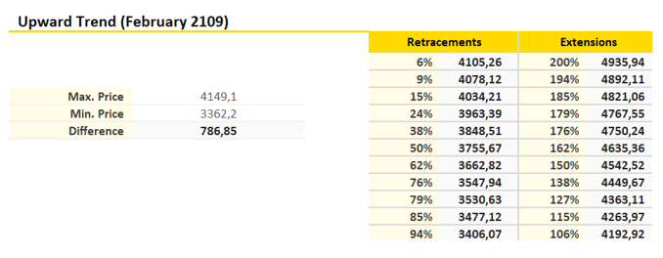

*Figure 2.* Fibonacci Extensions applied to Bitcoin

**1.3.3 Moving Averages indicators**

MACD stands for ‘moving average convergence divergence.' It shows the relationship between two moving averages of prices. While the name may sound complicated, it is simple to use.

MACD is popular because of its ability to help quickly spot increasing short-term momentum which is helpful when creating your short-term strategies.

*Figure 3.* Moving Average Indicators applied to Bitcoin

The MACD is calculated by subtracting the value for the long-term moving average from the short-term average. In MACD calculations, 12 and 26-day exponential moving averages are used. The MACD can be customized to fit any strategy, but the defaults are these 26 and 12-day periods. The result of this calculation is plotted on the graph. A signal line is plotted on the MACD chart by using a 9-day exponential moving average calculation and works as a trigger for buy and sell points.

**Reading the Signs**

**Crossovers**

When the MACD falls below the signal line, it is a bearish signal. This typically means it may be time to sell. When the MACD rises above that signal line, it is a bullish signal, and the price is likely to continue moving upward. It is a safe strategy to wait until the MACD has risen.

**Divergence**

Divergence refers to when the two 12- and 26-days exponential moving averages begin to move apart. What this really means is a price low is not accompanied by a low of the MACD. This situation usually signals the end of a trend.

**Rising Dramatically**

When the short exponential moving average pulls away from the long-term version, it will show as the MACD rising drastically. This tends to be a sign that the cryptocurrency has been overbought but will return to normal levels soon.

**Position to the Zero Line**

Another signal to watch for is the position of the MACD is relation to the zero line. The zero line is often shown by a solid horizontal line on the charts. It represents the long-term average and acts as a support or resistance level. Upward momentum is represented by the MACD moving above the zero-line meaning the short-term average is above the long term. Reverse this situation, and a downward trend could be forming[10, p.79].

**1.3.4 Relative Strength Index RSI**

The relative strength index (RSI) shouldn’t be confused with relative strength which compares the performance of a coin’s price to the overall market average. RSI is a tool that investors can use to figure out if a coin has been overbought or oversold which can provide them with entry and exit signals. It can also help spot or confirm reversals through monitoring for divergences. It is a momentum indicator that measures the speed and change of price movements.

Values move back and forth between 0 and 100. When the RSI goes 70 or above, it indicates the coin has been overbought or overvalued. If it goes 30 or below, then it has been oversold or undervalued. In both situations, it is vulnerable to a trend reversal. The default time frame for comparing up periods to down periods is 14 trading days.

The RSI is also used to spot divergence. When the price is rising, but the RSI is falling, this is known as a bearish divergence. When buying momentum is slowing like this then this is a warning that the price could soon correct lower. Bullish divergence is when the price is falling, but the RSI is rising. It warns the price could soon move higher since selling momentum is slowing.

Each coin will move differently and could have different ranges. When you notice the pattern, adjust the level to suit the movements. This could mean 40 may be a better entry point than 30. False buy or sell signals can happen in the RSI if there are sudden large price movements. To offset this issue, some traders use higher and lower values such as 80 and 20 as buy or sell signals[10, p.81].

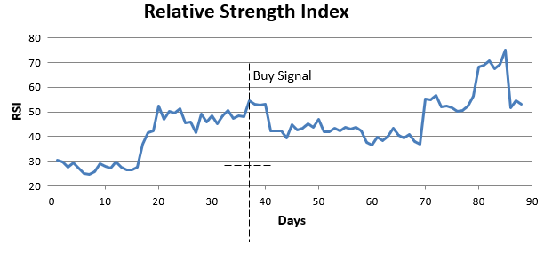

*Figure 4.* Relative Strength Index applied to Bitcoin

# **Chapter 2 Analysis of digital currency investment portfolio**

## **2.1 Digital currency dynamics**



**2.1.1 Review and analysis of financial information about the digital currency market**

To understand the cryptocurrency market, it is necessary to remember, as mentioned in chapter 1 (page 29), that the price of Bitcoin influences the credibility that investors usually deposit in altcoins, and other cryptocurrencies. Therefore, it is valid to analyze how the market for Bitcoin has evolved during the last two years. Especially since April 2017.

Cryptocurrency began to attract considerable attention from investors, when the price of Bitcoin reached the threshold of $ 1200 in April 2017 and the upward trend remained for long enough to unleash a massive purchase that culminated in the exuberant price of $ 18,000 in December 2017.

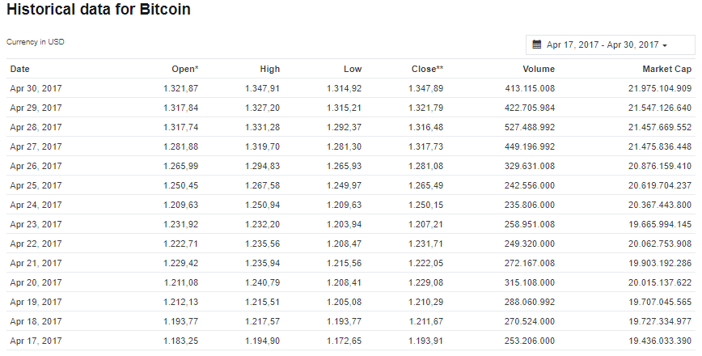

*Figure 5.* Bitcoin Bullish trend during the last two weeks of April 2017 [Adapted from 5]

Bitcoin had already reached a price of $ 1000 for the first time in November 2013 but the upward trend did not exceed 10 days. However, after this short period of rising, the price stabilized during a new period at a price around 300 dollars.

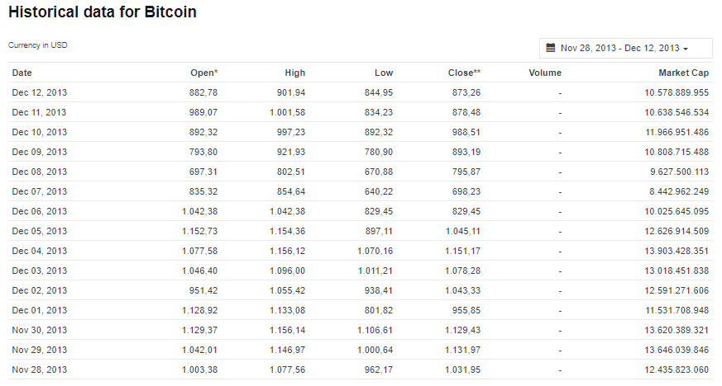

*Figure 6.* First time that Bitcoin price hit $1000 (November 2013) [Adapted from 5]

Bitcoin reached the price of $ 1000 for a second time on February 2017, but again the upward trend did not exceed 31 days.

The reason why reaching a price of $ 1000 for Bitcoin is so important, is because it is considered that Bitcoin has three phases: - Value reserve. - Exchange medium. - Unit of account[37].

It is considered that Bitcoin became a value reserve at the time it reached the price of 1 dollar in 2011, and it was when experts in computer science and digital economy recommended that investors should start buying Bitcoins. Since then, Bitcoin has been valued more than gold and the dollar since its creation. With the fall of Bitcoin at the beginning of the year 2018, the majority of investors worried only about the conversion of 1 BTC to USD, without analyzing the change in reverse, the price of a dollar in Bitcoin.

In other words, in 2011, 1 Bitcoin was necessary to buy 1 dollar and at this time (beginning of 2019), only about 0.00028 BTC is needed to buy a dollar and this data alone demonstrates the loss of value of dollar against Bitcoin.

Similarly, gold has been significantly devalued since 2011, when the price of an ounce of gold cost $ 1,800. Throughout that year, the price of Bitcoin ranged between $ 0.30 and $ 4. At the beginning of 2019, the price of Bitcoin exceeded $ 3000 (see Figure A13, Appendix A) and the price of an ounce of gold costs $ 1200. This shows that in the span of eight years, gold has lost 33% of its value, while Bitcoin has experienced an increase of 13900% in its value[38].

When the price reached $ 1200 and maintained its upward trend, financial companies began to launch the market of Bitcoin Futures contracts. The first company that launched these types of contracts was the US financial firm Cboe Global Markets.

This type of contract is based on the exchange of an asset, fixing its price at the time the contract is agreed, but which will be effected on a previously determined date. Other financial companies such as LedgerX, Ukrainian Exchange, Vontovel Investment Banking, also made official the launch of Bitcon's future contracts since 2017, demonstrating the importance of Bitcoin as a reserve currency[39].

*Figure 7.* Bitcoin Price evolution during the last 7 years

It’s possible to observe on the previous chart, that every time an upward trend occurs, the price of Bitcoin experiences a downward trend and the price stabilizes at a new higher price. After the first time the price reached a thousand dollars, the price of Bitcoin readjusted around 300 dollars, and after reaching almost 19,000 dollars the price remained stable around 3000 dollars, to continue from there with a new upward trend that has been maintained since March 2019 until May 2019

After the fall of Bitcoin during 2018, the majority of initial currency offerings (ICOS) began to decline, to the point that the ICOS market is considered practically dead[39]. Due to this situation, this type of coins will not be taken into consideration to be included in the portfolio.

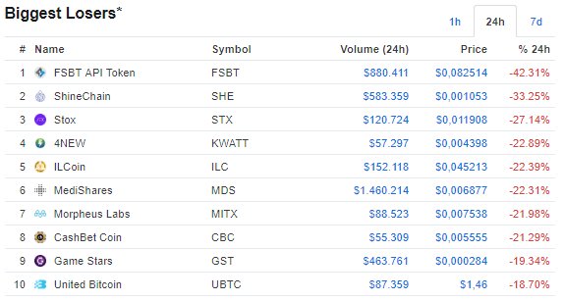

*Figure 8.* Top 10 biggest losers at beginning of 2019 in the market of ICOS [Adapted from 5]

**Bitcoin Dominance Index**

A very important factor that must be taken into consideration, is what is known as Bitcoin Dominance Index, that is defined as the percentage of the total cryptocurrency market capitalization that Bitcoin takes up at any given point in time. For example, if Bitcoin dominance is 37.2%, this means that the total value of Bitcoin takes up 37.2% of the entire market.

This index is closely related to the evolution of the other crypto currencies, because when the BTC Dominance Index starts to fall, this means that investors after having obtained money due to the growth of Bitcoin, begin to invest in other lower priced cryptocurrencies that begin to have more participation in the market, momentarily taking over the Bitcoin. Investors do this, with the aim of making more money (if they invest in the correct currencies).

During the end of 2018 and the beginning of 2019, the BTC Dominance Index has remained low, around 50.7% and this could indicate according to what was mentioned in the previous paragraph, that it is a good idea to invest in altcoins during the year 2019[40].

The selection of cryptocurrency chosen as a case study was made based on the cryptocurrency and altcoins that dominate the market at the end of 2018 and the beginning of 2019 and in the information mentioned above. (See Figure A1, Appendix A).

The decision to have chosen Stable Coins as TrueUSD and USD Coin as research subject instead of ICOS, is due to the analysis of the Bitcoin dominance index, which leads to the disappearance of the altcoins and tokens that have less support from the industry (See Figure B1, Appendix B).

**2.1.2 List of the digital currencies and Tokens selected as subject of study**

The investment portfolio will be diversified, investing in the crypto currencies that occupy the first five positions in January 2019, and including the Tokens, USD coin and TrueUSD, due to their position in the ranking, the high level of reliability and the upward trend that can be observed in the graphs.

The chosen digital currencies and Tokens are:

Bitcoin XRP Ethereum Bitcoin Cash

EOS USD Coin TrueUSD

## **Fundamental and Technical Analysis of cryptocurrencies**

**2.2.1 Review of the evolution of prizes and capitalization market of**

**the selected digital currencies, considering data corresponding to the**

**period between April 2017 and February 2019.**

**Bitcoin**

Source: [5]

Lowest Price (April 18, 2017 – Feb 28, 2019): $ 1.212,91

Highest Price (April 18, 2017 – Feb 28, 2019): $ 19.353,70

Capitalization market April 18, 2017: $ 19.746.690.286

Capitalization market February 28, 2019: $ 67.931.088.240 (Growth in the capitalization market 244% approximately).

Max Supply: 21.000.000 BTC

**XRP**

Source: [5]

Lowest Price (April 18, 2017 – Feb 28, 2019): $ 0,033387

Highest Price (April 18, 2017 – Feb 28, 2019): $ 3,65

Capitalization market April 1, 2018: 7$ 1.253.080.686

Capitalization market February 28, 2019: $ 13.031.821.008 (Growth in the capitalization market 939,98% approximately).

Max Supply: 100.000.000.000 XRP

**Ethereum**

Source: [5]

Lowest Price (April 18, 2017 – Feb 28, 2019): $ 50,82

Highest Price (April 18, 2017 – Feb 28, 2019): $ 1.389,18

Capitalization market April 18, 2017: $ 4.617.482.852

Capitalization market February 28, 2019: $ 14.494.279.216 (Growth in the capitalization market 213,900% approximately).

Max Supply: **No Data.**

**Bitcoin Cash (There is not information for April 2017, because the coin was launched on August 2017)**

Source: [5]

Lowest Price (August 1, 2017 – Feb 28, 2019): $ 287,57

Highest Price (August 1, 2017 – Feb 28, 2019): $ 4091,70

Capitalization market August 2, 2017 (one day after releasing): $ 7.796.599.604

Capitalization market February 28, 2019: $ 2.361.220.892 **(Decrease in the capitalization market 69,71% approximately).**

Max Supply: 21.000.000 BCH

**EOS (There is not information for April 2017, because the coin was launched at the end of June 2017)**

Source: [5]

Lowest Price (July 1, 2017 – Feb 28, 2019): $ 1,03

Highest Price (July 1, 2017 – Feb 28, 2019): $ 21,46

Capitalization market August 2, 2017 (two days after releasing): $ 731.088.773

Capitalization market February 28, 2019: $ 3.252.536.635 (Growth in the capitalization market 344.889% approximately).

Max Supply: **No Data.**

**USD Coin (There is not information for April 2017, because the coin was launched on October 2018).**

Source: [5]

Lowest Price (October 8, 2018 – Feb 28, 2019): $ 1

Highest Price (July 1, 2017 – Feb 28, 2019): $ 1,07

Capitalization market October 17, 2018 (16 days after releasing): $ 24.295.931

Capitalization market February 28, 2019: $ 233.867.951 (Growth in the capitalization market 862% approximately).

Max Supply: **No Data.**

**TrueUSD (There is not information for April 2017, because the coin was launched on March 2018).**

Source: [5]

Lowest Price (March 6, 2018 – Feb 28, 2019): $ 0,998462

Highest Price (March 6, 2018 – Feb 28, 2019): $ 1,13

Capitalization market March 13, 2018 (seven days after releasing): $ 6.566.124

Capitalization market February 28, 2019: $ 205.774.148 (Growth in the capitalization market 3000% approximately).

Max Supply: **No Data.**

**2.2.2 Fundamental and Technical analysis applied to investment**

**in the selected digital currencies and Initial Currency Offerings.**

**Investment Budget**

**Time:** 1 year[42], Short term.

**Amount of money:** 1000 us (Inspired on minimum budget to trade in stock market)[43].**Tolerable loss percentage**: 2% (following the 2% rule)[44].

**2) Financial Goal of the Portfolio**Trading and maximize profits to reinvest 25% of the investment in one year.

**Selling price:** 7%-8% below current closing price at 02/28/2019.**Discount rate:** 30-50% per annum[45].

**Stop loss:**

Bitcoin: 3215.7447 us

Ethereum: 99,5658 us

XRP: 0.28833348 us

Bitcoin Cash: 106.7733 us

EOS: 2.1576 us

TrueUSD: Doesn’t apply

USDcoin: Doesn’t apply

**Type of Portfolio**

Aggressive. High-risk/High-reward.

**Fees for purchasing cryptocurrencies:**

Bitcoin: 0,228 USD (27 January 2019)[46]

Ethereum: 0,0678 USD (27 January 2019)[46]

XRP: 0,0005 USD (27 January 2019)[46]

Bitcoin Cash: 0,0055 USD (27 January 2019)[46]

EOS: 0 USD [46]

TrueUSD: 0.1% BTC [47]

USDcoin: 0 USD.

**Fundamental Analysis**

The fundamental analysis applied to cryptocurrency is divided into three stages, which allow us to glimpse the best investment options as the theory explained in chapter 1 is applied to the selected currencies.

**Stage 1: Theoretical criteria to select cryptocurrencies, altcoins, crypto tokens, and Initial Currency Offerings to invest.**

In this stage, the criteria explained in the chapter 1 were selected, and adjusted to the information available on the different online platforms, in order to determine the best investment options, within the set of currencies selected as subject of study:

The following criteria were selected to perform the first stage of the analysis:

* Reliability: Related to the concept of avoid the pump and dump mentioned in the chapter 1 (page 14).
* Business Plan.
* Website.
* Activity in social media.
* Ranking on trading platforms.

(The following table is based on information collected on January 27, 2019)

**Table 1** *Criteria to select cryptocurrencies (altcoins, tokens).*

|  |  |  |  |  |  |
| --- | --- | --- | --- | --- | --- |
| **COIN** | **RELIABILITY** | **BUSINESS PLAN** | **WEBSITE** | **ACTIVITY IN SOCIAL MEDIA** | **RANKING ON TRADING PLATFORMS** |
| **BITCOIN** | 10 years in circulation[48]  First cryptocurrency [48]  Companies that accept Bitcoin[49] | Solution to the double-spending problem  12 Projects in progress using the Bitcoin Blockchain[50] | <https://bitcoin.org/en/>  Access to:   * Individuals * Businesses * Developers * Technical information | [BitcoinTalk Forum](https://bitcointalk.org/)  [Reddit's Bitcoin Community](https://reddit.com/r/Bitcoin/)  [Bitcoin StackExchange (Q&A)](https://bitcoin.stackexchange.com/)  [Google+ Bitcoin Community](https://plus.google.com/communities/115591368588047305300)  [Twitter Search](https://twitter.com/search?q=bitcoin)  [Facebook Page](https://www.facebook.com/bitcoins) | 1 |
| **ETHEREUM** | 6 years in circulation[51]  Used by enterprise software companies (Microsoft, IBM, JPMorgan Chase, Deloitte, R3, Innovative UK[52] | Creation of Smart Contracts for several applications, without any possibility of downtime, censorship, fraud or third-part interference  [53] | [www.ethereum.org](http://www.ethereum.org)  Access to:   * Individuals * Businesses * Developers * Technical information | Blog  GitHub  YouTube  Reddit  Gitter  Twitter  Stack Exchange  Facebook  Meetups | 3 |
| **XRP** | 7 years in circulation  Created by Ripple Labs, Inc[54] | Implementation of a distribuited payment system[54] | <https://ripple.com/>  Access to:   * Global Payments * Banks * Payment Providers * Developers * Technical information | Facebook  Twitter  Linkedin | 2 |
| **BITCOIN CASH** | One and a half year in circulation  Supported by Bitcoin Project | Same purposes of Bitcoin with lower fees and more reliable confirmations  [55] | <https://www.bitcoincash.org/>  Access to :   * Individuals. * Technical information | /R/BTC.  SLACK.  Facebook.  Telegram.  Githum | 5 |
| **EOS** | 1 year.  Created by block.one company[56] | To solve scalability issues of blockchains.  To create the most powerful infraestructure to decentralized applications [56] | <https://eos.io/>  Access to:   * Individuals * Developers | Facebook  Twitter  Instagram  YouTube  Github  Medium | 4 |
| **TRUE USD** | 10 months  Backed up by Stanford University[57] | To create a stable coin that is 100% legally backed by US dollars (crypto-dollar)[57] | <https://www.trusttoken.com/trueusd/>  Access to:   * Individuals * Developers * Technical information | Twitter  Facebook  Github  Telegram | 26 |
| **USD COIN** | 4 months  Backed up by circle company (6 years)[58] | Smart contract based stable coin[58]  Allow fiat to interact with smart contracts | <https://www.centre.io/usdc>  Access to:   * Individuals * Developers * Technical information | Blog | 19 |

**Results of Stage 1 of Fundamental Analysis**

According to the selection criteria. Bitcoin, Ethereum and XRP are projects with experience between 6 and 10 years. Experience of the companies behind the project it is considered a factor of reliability when investing according to Fundamental analysis approach.

Bitcoin, Ethereum and XRP, have the support of important technology companies, a clear and differentiated business plan and a good perspective of sustainability in the future (represented by technological innovation), which gives value to the investment. These coins occupy the first three positions in the ranking platforms and have more activity in social media. These factors are considered important too in the world of technology.

TrueUSD and USDCoin, are digital versions of dollar or Stable Coins. (Stable Coins, are defined as coins designed to minimize the effects of prize volatility).

BitcoinCash, E0S, TrueUSD and USD Coin, are projects with short experience in the market.

The business plan related to EOS is interesting, because several companies are looking for implementing Blockchain technologies on different new projects in the future, and the EOS project, offers a solution to this kind of problem. It’s position in the ranking (4th) is better than Bitcoin Cash. Bitcoin Cash is very similar to Bitcoin on its business plan.

**Stage 2: Other indicators that determine the optimal price of a coin**

In this stage, additional criteria explained in the chapter 1, and checklist criteria were selected and adjusted to the information available on the different online platforms, in order to narrow the set of best investment options, within the set of currencies selected as subject of study:

* Objective. – Usage. – Paper. – Plan. – Backup.
* Centralization. – Money raised/spent. – Differentiation. – Target market. – Legal barriers. – Supply. – Market capitalization.
* Team.

(The following table is based on information collected on January 27, 2019)

**Table 2** *Rating Checklist*

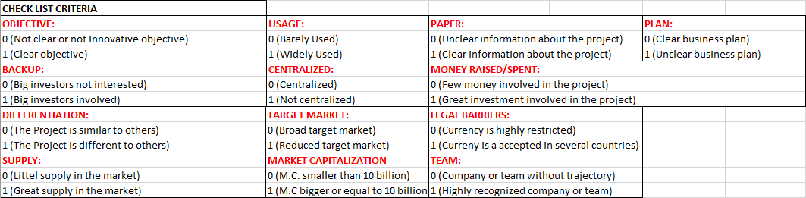

The scores assigned to each criterion depend on the way in which each currency complies with the selected criteria (0 for a poor performance and 1 for a high performance). In the end it was decided to assign an average score for each criterion, and in this way to have a more approximate idea about the cryptocurrency that will be included in the final portfolio.

(The following table is based on information collected on January 27, 2019

**Table 3** S*cores for each coin*

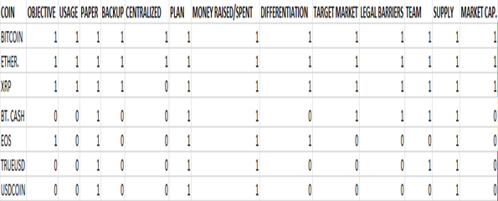

T**able 4** *Average score for each coin*

|  |  |
| --- | --- |
| **COIN** | A**VERAGE SCORE** |
| **BITCOIN** | 1 |
| **ETHER.** | 1 |
| **XRP** | 0,923076923 |
| **BITCOIN CASH** | 0,538461538 |
| **EOS** | 0,461538462 |
| **TRUE USD** | 0,384615385 |
| **USDCOIN** | 0,307692308 |

In the previous table, the cells in green represent the cryptocurrencies in which it is advisable to invest according to the average score, the cells in yellow represent the cryptocurrencies that are considered an interesting investment but that could be risky and the cells in red color, represent the cells in which it is not advisable to invest.

**Results of Stage 2 of Fundamental Analysis**

The green color, represents the three more reliable investments (Bitcoin, Ether, XRP). The average score of BitcoinCash is higher than EOS, but the EOS individual scores in items like Objective and Differentiation, are better, so the investment on EOS is considered advisable at the end of this stage of the analysis.The average score of TrueUSD, and USD coin, are the worst, among the 7 coins. These projects are not interesting from the point of view of objective and differentiation. (There were similar projects before, associated to stable coins backed up by dollar), and as the dollar is being threatened by the rise of Bitcoin and the global geopolitical situation, investment in these types of dollar-to-dollar backed currencies goes against the philosophy of financial freedom that led to the origin of digital currency.

**Stage 3: Trigger of market dynamics**

In this stage, some triggers for market dynamics, are taken into consideration, in order to have a final idea about the creation of investment portfolio. The triggers for market dynamics chosen for evaluation are listed below:

* Demand.
* Supply.
* Perception of specialists. (Great specialists such as the winner of the Nobel Prize for economics, Paul Krugman, have gone on to support cryptocurrency, after having been great detractors[59].
* Prominent investors.
* Innovation.
* Instability.
* Bear/Bull markets.

(The following table is based on information collected on January 27, 2019)

(The information collected for each coin, was extracted from the list of resources cited in the table D1 see Apendix D).

**Table 5** *Reasons for market dynamics*

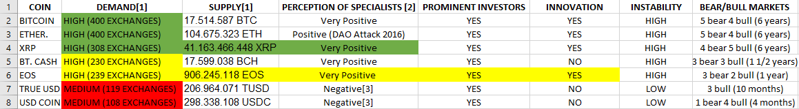

**Results of Stage 3 of Fundamental Analysis**

Bitcoin, Ether and XRP, have a high demand and supply. XRP has a high supply and more bull markets than bear markets. However, while the offer of Bitcoin and XRP is finite, making them deflationary cryptocurrencies that will acquire great value in the future, the supply of Ethereum is unlimited and this factor reduces the credibility of this digital currency (see please, page 43 of second chapter).

The demand and supply for EOS is higher than BitcoinCash, and the project is more innovative than BitcoinCash, but the supply of EOS is infinite,   
and this factor is reminiscent of fiat money, which causes mistrust within the group of financial freedom advocates that characterizes Bitcoin as an original cryptocurrency. All the main cryptocurrencies have a very positive perception from the public. TrueUSD and USDcoin are negatively perceived and no innovative, and their value is increasingly threatened, as the dollar that backs up them, loses its value against Bitcoin.

**Conclusions of Fundamental Analysis.**

**Cryptocurrencies with fixed supplies have more value**

The world’s biggest cryptocurrency, Bitcoin, has a fixed supply of 21 million USD, [and last April](https://cointelegraph.com/news/17-mln-of-total-21-mln-bitcoins-now-mined-in-milestone-for-digital-scarcity), it was confirmed that 80 percent of this total had already been mined. Although newly minted Bitcoins aren’t going to be around forever, as the number available is going to decrease over time, there’s still a long way to go before they will all enter circulation. In fact, as things stand, the supply of new coins won’t be fully exhausted until 2140. Depreciation is impossible when an asset is finite, and this creates the risk of crypto owners waiting to get their goods cheaper. When it comes to conventional currencies, inflation is something that disincentivizes consumers from holding onto their cash — the longer it’s in their wallet, the less purchasing power it has[60].

In section 2.2.1 of this chapter, a review was made of the evolution of prices and the capitalization market of cryptocurrency selected as a case study. Within this set of cryptocurrencies, Bitcoin, XRP and Bitcoin Cash, are the only ones that have a limited supply and, as with gold, due to the fact that the offer of these currencies has a limited existence, this factor, converts these digital currencies into assets that can not be depreciated.

According to these criteria, the most reliable investment should be made in Bitcoin, XRP, and Bitcoin Cash.

**Growth and decrease of capitalization market**

Another important factor that must be taken into consideration is the growth and decrease of the capitalization market.

The statistics shown in section 2.2.1 give an idea of ​​the hypothesis about the advisability of investing in the XRP project. This cryptocurrency has a capital market growth of approximately 938.98% and maintains a very attractive price for investors (less than a dollar).

The growth of the Bitcoin, Ethereum and EOS capitalization market is also interesting because it exceeds the 200% value and this factor makes these currencies an interesting investment.

The highest growth in the capitalization market is presented by TrueUSD and USDCoin, but as it is mentioned in the theoretical chapter, it is possible that this high percentage of growth is due to some effort of large investors to try to rescue the dollar, and for this reason it is not considered a good idea to invest on this coins.

According to these criteria, the most profitable investments should be made on Bitcoin, XRP, Ethereum and EOS. The decrease on the capitalization market of Bitcoin Cash it is considered another reason to prefer EOS, over Bitcoin Cash.

Investment on TrueUSD and USD must to be discarded. Investing on these coins, would be very expensive for a small investor looking for maximizing profits in short term. Investment on EOS represents a better alternative than BitcoinCash, because the project involves technological innovation and improvements to the Blockchain systems.

The final conclusion of Fundamental Analysis is that, the investment should be made on Bitcoin, XRP, Ethereum and EOS.

The three preliminary portfolios corresponding to Fundamental Analysis, are shown in Appendix E.

**Technical Analysis**

**Preliminary considerations**

Taking into consideration the fundamental analysis carried out previously, the possibility of investing in Stable Coins (coins backed 1 to 1 with the US dollar) is discarded, due to the risk of digitizing dollars, and because these currencies are somewhat against of the principles that led to the creation of digital currency.

The first step to follow, to carry out the technical analysis, is to calculate the return, the average return and risk for each cryptocurrency. (The calculations were made using Excel, using close prices from April 18 2017, until February 28 2019). Source[61].

**Bitcoin**

|  |  |  |
| --- | --- | --- |
| **Average Return** |  | **Risk** |
| 0,279982633 |  | 4,681 |
|  |  |  |
|  |  |  |

**XRP**

|  |  |  |
| --- | --- | --- |
| **Average Return** |  | **Risk** |
| 0,679654587 |  | 8,892076 |

**Ethereum**

|  |  |  |
| --- | --- | --- |
| **Average Return** | | **Risk** |
| 0,348749231 |  | 6,311303 |
|  |  |  |

**Bitcoin Cash** (Data available since July 31 2017)

|  |  |  |
| --- | --- | --- |
| **Average Return** |  | **Risk** |
| 0,199336608 |  | 9,340126 |

**EOS** (Data available since June 29 2017)

|  |  |  |
| --- | --- | --- |
| **Average Return** |  | **Risk** |
| 0,730023181 |  | 11,78832 |

According to the data, EOS represents the riskiest investment option., but at the same time EOS is the option with the highest rate of return.

Bitcoin Cash has a high level of risk but the return is very low in comparison with EOS. According with this information EOS represents a better option of investment than Bitcoin Cash.

**Bitcoin**

|  |  |  |
| --- | --- | --- |
| **Average Return** |  | **Risk** |
| 0,279982633 |  | 4,681 |
|  |  |  |
|  |  |  |

**XRP**

|  |  |  |
| --- | --- | --- |
| **Average Return** |  | **Risk** |
| 0,679654587 |  | 8,892076 |

**Ethereum**

|  |  |  |
| --- | --- | --- |
| **Average Return** | | **Risk** |
| 0,348749231 |  | 6,311303 |

Among these three cryptocurrencies, XRP represents the riskiest investment option, but at the same time the option with the highest rate of return.

Ethereum represents an intermediate point between XRP and Bitcoin, and according to Risk and Average Return approach, it is more reasonable to invest in Ethereum rather than XRP.

Bitcoin represents a less risky investment, compared to the other cryptocurrencies analyzed. Although it is the currency that offers the lowest average rate of return. Investing in Bitcoin is considered a way to secure the money invested in a diversified portfolio of cryptocurrencies.

The second step is to perform an analysis of covariance and volatility. In order to to evaluate the convenience of investing in each of the selected digital currencies, it is necessary first, to calculate and weigh the covariance of each of them with respect to Bitcoin, because from the beginning of cryptocurrency market, Bitcoin has an index of dominance in the market higher than 50% and because Bitcoin has been selected as a safe investment that will always be present in the diversified portfolio (The calculations were performed for 577 days in order to have a better idea about the results., due to some of the cryptocurrencies were created after Bitcoin.

|  |  |  |  |  |
| --- | --- | --- | --- | --- |
| **Covariance(Bitcoin, Ethereum)** | 17,8784 |  | **Covariance(Bitcoin, XRP)** | 16,80404 |
| **Variance Bitcoin** | 22,6039 |  | **Variance Bitcoin** | 22,6039 |
| **Beta** | 0,790942 |  | **Beta** | 0,743412 |
|  |  |  |  |  |
|  |  |  |  |  |

|  |  |  |  |  |
| --- | --- | --- | --- | --- |
| **Covariance(Bitcoin, EOS)** | 1,562929 |  | **Covariance(Bitcoin,Bitcoin Cash)** | 2,604872 |
| **Variance Bitcoin** | 22,6039 |  | **Variance Bitcoin** | 22,6039 |
| **Beta** | 0,069144 |  | **Beta** | 0,11524 |

In all cases, the covariance is positive, which means that there is a positive dependence between Bitcoin and the other digital currencies.

The two cryptocurrencies that follow the growth trend of Bitcoin in greater magnitude are Ethereum and XRP.

The growth trend of EOS and Bitcoin Cash is not so high in relation to Bitcoin.

Beta factor values ​​are positive for all cryptocurrencies, compared to the market dominated by Bitcoin but all values ​​are less than 1. This means that none of the markets for the other cryptocurrency is more volatile than the Bitcoin market.

The two least volatile currencies in comparison with the Bitcoin market are EOS (93% less volatile than the Bitcoin market) and Bitcoin Cash 88% less volatile than the Bitcoin market). For this reason, taking into consideration the principle of portfolio diversification, EOS represents a good investment option.

The third stage of analysis involves the uses of indexes, in order to analyze the best possibilities of investment.

## **Use of indexes, applied to the technical analysis of digital currencies**

**2.3.1 Candlestick analysis**

After performing the analysis of the charts, it is possible to observe how the main cryptocurrencies follow the trend of Bitcoin on the same dates.

**Bitcoin Candlesticks analysis** (February 2019) (See Appendix F, Figure F.1).

At the end of the first week of February 2019, the candlestick chart shows an upward trend, from 3363,32 USD to 4149,08 USD on February 23, with a correction of 3830,71USD at the end of the month, finishing with a very small downward trend. It is considered advisable to invest, because the upward trend could continue during the next month.

**XRP Candlesticks analysis** (February 2019) (See Appendix F, Figure F.2).

At the end of the first week of Februay 2019, the candlestick chart shows an upward trend, from 0,2897 USD to 0,3362 USD on February 23, with an adjustment of 0,3136 USD at the end of the month, finishing with a downward trend. It is considered advisable to invest.

**Ethereum Candlesticks analysis** (February 2019) (See Appendix F, Figure F.3).

At the end of the first week of February 2019, the candlestick chart shows an upward trend, from 103,51 USD to 159,47 USD on February 23, with a correction of 135,94 USD at the end of the month, finishing with a very small downward trend. It is considered advisable to invest, because the upward trend could continue during the next month.

**Bitcoin Cash Candlesticks analysis** (February 2019) (See Appendix F, Figure F.4).

At the end of the first week of February 2019, the candlestick chart shows and upward trend, from 113,58 USD to 154,07 USD on February 23, with a correction of 131,19 USD at the end of the month, finishing with a very small downward trend. It is considered advisable to invest, because the upward trend could continue during the next month.

**EOS Candlesticks analysis** (February 2019), (See Appendix F, Figure F.5).

At the end of the first week of February 2019, the candlestick chart shows and upward trend, from 2.36 USD to 3 USD on February 23, with a correction of 2.92 USD at the end of the month, finishing with an upward trend. It is considered advisable to invest, because the upward trend could continue during the next month.

* + 1. **Fibonacci retracements and extensions applied to the selected digital currencies**

**Bitcoin**

*Figure 9.* Bitcoin upward trend (February 2019)

**Table 6** *Fibonacci Retracements and extensions applied to Bitcoin during upward trend (February 2019)*

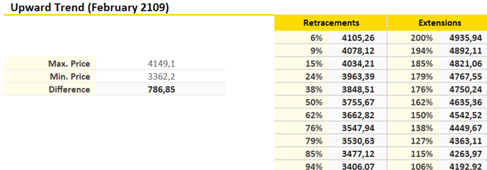

The retracement at the 62% point is greater than the price at the beginning of the trend, and the difference is 786,85 USD, therefore it is assumed that the price will not decrease in the near future. It is possible to observe, the price advances from one extension level to the next and this is an indicator that the upward trend will continue over the next few days. It is highly recommended to invest.

**XRP**

*Figure 10.* XRP upward trend (February 2019)

**Table 7** *Fibonacci Retracements and extensions applied to XRP during upward trend (February 2019)*

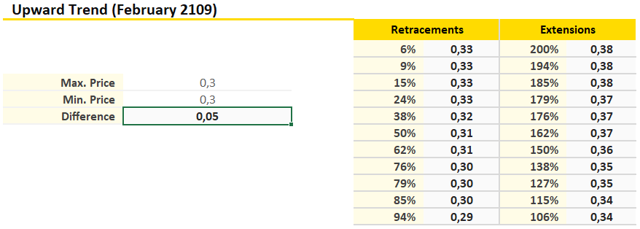

The retracement at the 62% point is greater than the price at the beginning of the trend, therefore it is assumed that the price will not decrease in the near future. It is possible to observe that the prices are duplicated in some extension levels. It is not possible to assume that the upward trend is going to continue. Investment could involve risk.

**Ethereum**

*Figure 11.* Ethereum upward trend (February 2019)

**Table 8** *Fibonacci Retracements and extensions applied to Ethereum during upward trend (February 2019)*

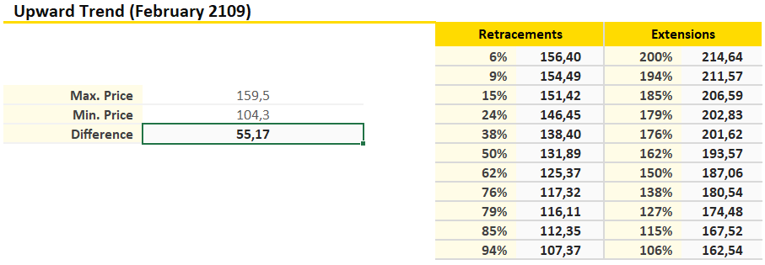

The retracement at the 62% point is greater than the price at the beginning of the trend, and the difference is 55,17 USD, therefore it is assumed that the price will not decrease in the near future. It is possible to observe, the price advances from one extension level to the next and this is an indicator that the upward trend will continue over the next few days. It is highly recommended to invest.

**Bitcoin Cash**

*Figure 12.* Bitcoin Cash upward trend (February 2019)

**Table 9** *Fibonacci Retracements and extensions applied to Bitcoin Cash during upward trend (February 2019)*

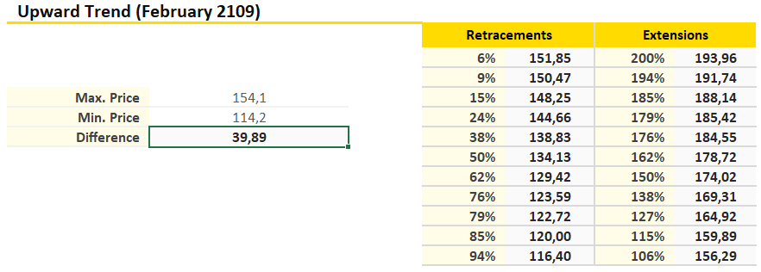

The retracement at the 62% point is greater than the price at the beginning of the trend, and the difference is 39,89 USD, therefore it is assumed that the price will not decrease in the near future. It is possible to observe, the price advances from one extension level to the next and this is an indicator that the upward trend will continue over the next few days. It is highly recommended to invest.

**EOS**

*Figure 13.* EOS upward trend (February 2019)

**Table 9** *Fibonacci Retracements and extensions applied to EOS during upward trend (February 2019)*

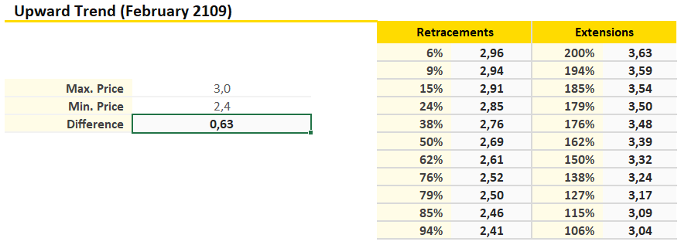

The retracement at the 62% point is greater than the price at the beginning of the trend, therefore it is assumed that the price will not decrease in the near future. It is possible to observe, the price advances from one extension level to the next and this is an indicator that the upward trend will continue over the next few days. It is highly recommended to invest.

* + 1. **Moving Averages applied to the selected digital currencies and Initial Currency Offerings.**

**Bitcoin**

*Figure 14.* Moving Average for Bitcoin (February 2019)

It is possible to observe that the price tends to stay above the moving average and this means that the upward trend will continue in the near future. Nevertheless, the lines are overlapped in some points, but investment is still advisable.

**XRP**

*Figure 15.* Moving Average for XRP (February 2019)

It is possible to observe that the price tends to stay above the moving average and this means that the upward trend will continue in the near future, but there are some spaces of separation between the two lines. Investment could involve risk.

**Ethereum**

*Figure 16.* Moving Average for Ethereum (February 2019)

It is possible to observe that the price tends to stay above the moving average and this means that the upward trend will continue in the near future. Nevertheless, the lines are overlapped in some points, but investment is still advisable.

**Bitcoin Cash**

*Figure 17.* Moving Average for Bitcoin Cash (February 2019)

It is possible to observe that the price tends to stay above the moving average and this means that the upward trend will continue in the near future. Nevertheless, the lines are overlapped in some points, but investment is still advisable.

**EOS**

*Figure 18.* Moving Average for EOS (February 2019)

It is possible to observe that the price tends to stay above the moving average and this means that the upward trend will continue in the near future. Nevertheless, the lines are overlapped in some points. According to this approach, investment is highly advisable.

**2.3.4 Relative Strength Index RSI applied to the selected digital currencies and Initial Currency Offerings.**

Close prices of cryptocurrencies since 12/02/2018 until 02/28/2019.

**Bitcoin**

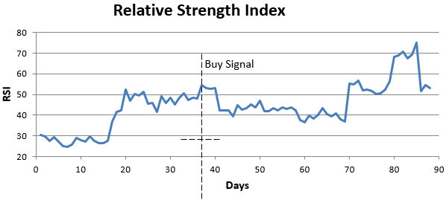

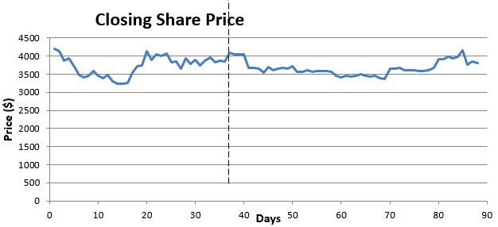

*Figure 19.* RSI for Bitcoin

The RSI for Bitcoin, is above 50 at the end of February 2019 (RSI above 50 is related with a Bullish trend and for this reason it is considered advisable to invest, but it’s possible to observe an overvalue trend and a small correction in the price. The investment could involve certain level of risk but it is still advisable to invest.

**XRP**

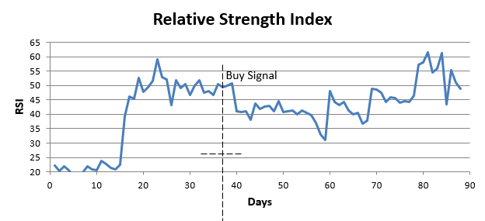

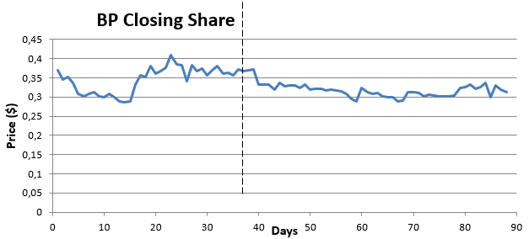

*Figure 20.* RSI for XRP

The RSI for XRP, is above 50 at the end of February 2019 (RSI above 50 is related with a Bullish trend but in this case the trend did not last for long time). The investment involves risk, because the price at the end is higher than at the beginning of the upward trend.

**Ethereum**

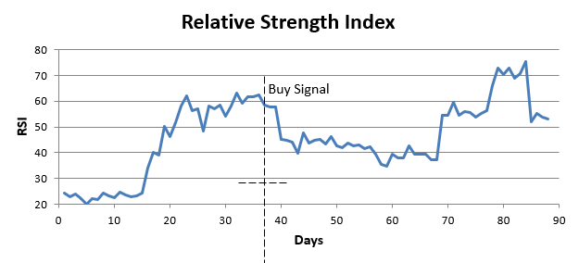

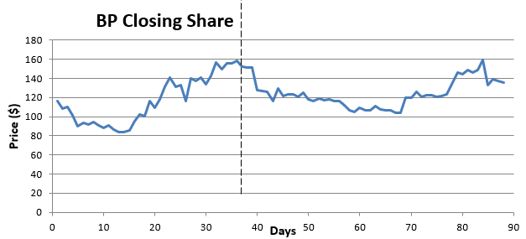

*Figure 21.* RSI for Ethereum

The RSI for Ethereum, is above 50 at the end of February 2019 (RSI above 50 is related with a Bullish trend). In this case according to the chart, the upward trend seems to be stable. It is highly advisable to invest, because the price is higher than at the beginning of the upward trend.

**Bitcoin Cash**

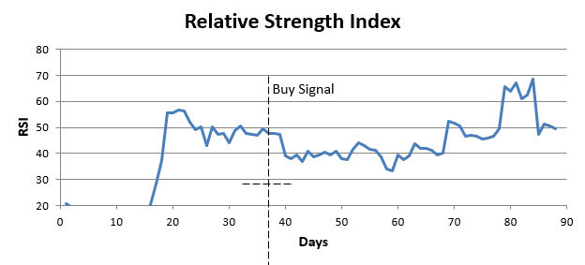

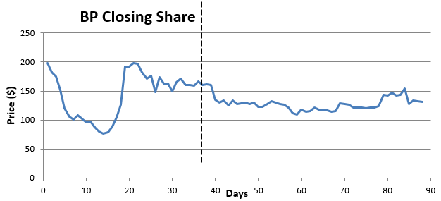

*Figure 22.* RSI for Bitcoin Cash

The RSI for Bitcoin Cash, is above 50 at the end of February 2019 (RSI above 50 is related with a Bullish trend but in there is a bearish tendency at the end of the month. Investment could be non as profitable as on other cryptocurrencies, because at the end was overbought and the price went down.

**EOS**

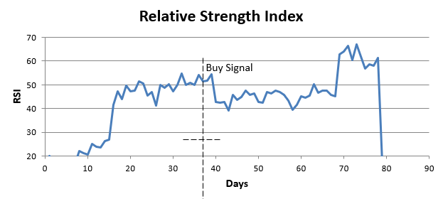

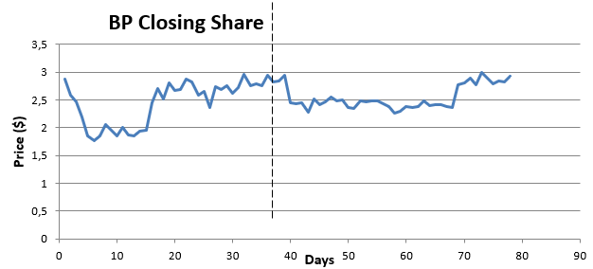

*Figure 23.* RSI for EOS

The RSI for EOS, is above 50 in February 2019 (RSI above 50 is related with a Bullish trend but in there is a bearish tendency at the end of the month). Investment could be stable because the price at the end went back to the price at the beginning of the upward trend.

**Conclusions of Fundamental Analysis**

**Table 6** *Results of Technical Analysis*

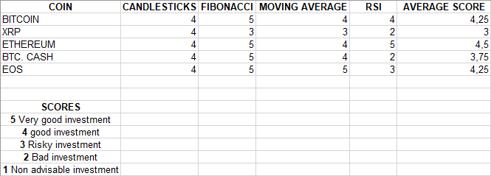

According to the results of the different types of indexes, the more advisable investment should be made on Bitcoin, Ethereum and EOS.

According to the return/risk analysis, EOS and XRP, represent a risky investment with high possibilities of return, Bitcoin represents the less risky investment and Ethereum represents and intermediate point.

According to the covariance/volatility analysis (against Bitcoin), Ethereum and XRP represent the safest options of investment, and EOS a very good option to diversify the portfolio.

The final conclusion of Technical Analysis is that, the investment should be made mostly on Bitcoin, Ethereum and EOS, and a part of the budget could be used to invest in XRP.

The three preliminary portfolios corresponding to Technical Analysis, are shown in Appendix G.

# **Chapter 3 Final portfolio design and analysis of the evolution of the investment at the end of May 2019**

## **3.1 Comparison of the results obtained according to fundamental and technical analysis**



**3.1.1 Results of Fundamental Analysis**

The fundamental analysis led to the creation of three preliminary portfolios with the following characteristics:

**Portfolio 1:**

* Bitcoin: Investment 50% (500 USD).
* XRP: Investment 25% (250 USD).
* Ethereum: Investment 25% (250 USD).

**Portfolio 2:**

* Bitcoin: Investment 50% (500 USD).
* XRP: Investment 40% (400 USD).
* EOS: Investment 10% (100 USD).

**Portfolio 3:**

* Bitcoin: Investment 50% (500 USD).
* Ethereum: Investment 50% (500 USD).

Bitcoin is considered the strongest cryptocurrency in the market and due to its strength against other traditional currencies such as the dollar and gold (see table 7), it is considered from the point of view of fundamental analysis, that regardless of the budget assigned to other cryptocurrency, the final portfolio must contain at least a fifty percent of the budget allocated to the purchase of Bitcoin.

**Table 7** *Relative Strength of Bitcoin vs Gold – Long term statistics (Two years of more)*

|  |
| --- |
| 24-month BTCUSD performance: +311.02 percent |
| 24-month GLD performance: +11.20 percent |
| **RS winner: BTCUSD** |
| 36-month BTCUSD performance: +860.84 percent |
| 36-month GLD performance: +18.37 percent |
| **RS winner: BTCUSD** |
| Five-year BTCUSD performance: +466.16 percent |
| Five-year GLD performance: +3.29 percent |
| **RS winner: BTCUSD** |

*Note.* Source of data: <https://coincentral.com/bitcoin-vs-gold-a-relative-strength-comparison/>

XRP and Ethereum appear in two of the portfolios designed according to fundamental analysis approach and it is considered a wise decision to select a portfolio that contains Bitcoin, XRP and Ethereum as a result of this stage.

* + 1. **Results of Technical Analysis**

The technical analysis led to the creation of three preliminary portfolios with the following characteristics:

**Portfolio 1:**

* Bitcoin: Investment 50% (500 USD).
* Ethereum: Investment 25% (250 USD).
* EOS: Investment 25% (250 USD).

**Portfolio 2:**

* Bitcoin: Investment 50% (500 USD).
* XRP: Investment 10% (100 USD).
* EOS: Investment 40% (400 USD).

**Portfolio 3:**

* Bitcoin: Investment 50% (500 USD).
* Ethereum: Investment 20% (200 USD).
* XRP: Investment 30% (300 USD).

Bitcoin is considered the strongest cryptocurrency in the market and because according to technical analysis it represents the investment that involves the least amount of risk, it is considered that the final portfolio must contain at least 50% of the budget, destined to the purchase of Bitcoin.

In the case of technical analysis, the final result shows that it is advisable to invest in EOS, due to its lack of correlation with the fluctuations of Bitcoin, and other cryptocurrencies. EOS is considered an excellent alternative to diversify the portfolio and despite the risk involved in investing in EOS, the promise of return is high. Therefore, it is considered a wise decision to select a portfolio that contains Bitcoin, EOS, and Ethereum as a result of this stage.

* + 1. **Comparison between the results obtained from fundamental analysis and technical analysis.**

The results of the fundamental and technical analysis led to similar conclusions. According to the fundamental analysis, the investment should be made in Bitcoin, XRP, Ethereum and EOS, discarding Bitcoin Cash. According to the technical analysis, the investment should be made in Bitcoin, Ethereum and EOS, allocating a small percentage to XRP, but according to technical analysis, after performing the indexes analysis, the investment on Bitcoin Cash is more advisable than investing on XRP.

The available budget for the investment is quite small and the choice of the final portfolio should be aimed at minimizing the risk and optimizing the profits. It is probably not a good idea to diversify the portfolio too much, taking into account, the low budget available to make the investment.

When comparing the results of the two types of analysis, it is possible to observe that there is a portfolio that was taken into consideration both in the fundamental analysis and in the technical analysis. This portfolio includes Bitcoin, Ethereum and XRP, and is considered the ideal Portfolio from the point of view of risk minimization (Bitcoin is considered as the safest investment from the fundamental and technical analysis approaches), and from the point of view of maximization of return (XRP represents an option with high possibilities of return according to the technical analysis) and Ethereum represents an intermediate point.

An alternative diversified portfolio will also be considered with four digital cryptocurrencies in which an equal percentage will be granted to each one of them in order to analyze is on this case, high diversification could represent an increase in the possible profits.

## **Selection of the final portfolio**

**3.2.1 Final portfolio**

**Final Portfolio (February 29 2019):**

**Criteria to choose the portfolio:**

Budget: 1000 USD.

Diversification:

* Bitcoin.
* Ethereum.
* XRP.

Characteristics of the selected coins.

- Bitcoin (more stable in comparison with XRP and Ethereum, Bitcoin is the more important cryptocurrency). ROI (measured since the date that the coin was released) 5.767,37% [5]. Price (3871,65 USD on February 28 2019).

- Ethereum (Biggest return on investment). ROI 8.880,09% (measured since the date that the coin was released)[5] Price (137,99 USD on February 29 2019).

- XRP (Biggest growth in capitalization market). ROI 6.778,66% (measured since the date that the coin was released)[5] Price (0,21 USD on February 28 2019).

Assets allocation:

* Bitcoin: Investment 50% (500 USD). The main reason to allocate the 50% of the money to purchase Bitcoin is its high price, its stability and its positioning in the cryptocurrency market.
* Ethereum: Investment 40% (400 USD). The reason to allocate 40% of the money to purchase Ethereum is its big return on investment and its high price.
* XRP: Investment 10% (100 USD). The reason to allocate only 10% of the money to purchase XRP is its low price and high possibilities of return.

Criteria:

* Bitcoin is the most important cryptocurrency, and it’s advisable to invest at least the half of the investment budget on Bitcoin.
* The price of Bitcoin is very high and with 500 USD it’s only possible to buy 0,12916 Bitcoin (In the cryptocurrency market it’s possible to purchase subdivisions of Bitcoin known as Satoshis). Ethereum is more affordable. The price allows the investor to get at least 2,8987 units with 400 USD.
* XRP allows to buy 476,19 coins with 100 USD. This small investment minimizes the risk.
* Ethereum is an expensive coin but it offers a very high return of investment. It is considered advisable to allocate a high percentage of the investment to this cryptocurrency.

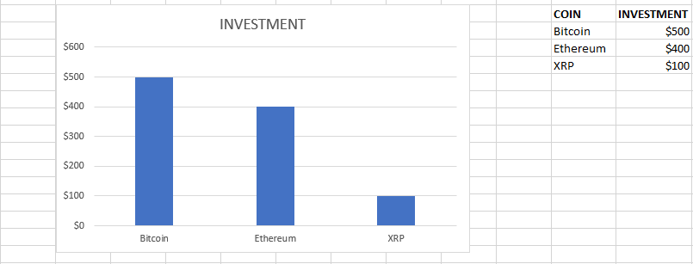

*Figure 24.* Final Portfolio

**3.2.2 Comparison of the final selected portfolio with the evolution of the cryptocurrency market at the end of May 2019.**

**Bitcoin**

Price on February 28 – 2019 (Day of purchase): 3854,79 USD[5].

Price on May 24 – 2019 (Day of evaluation): 7987,37 USD[5].

Money invested: 500 USD.

Amount of Bitcoin purchased: 0,129 BTC.

Value of Bitcoin purchased on May 24 2019 (After three months): 1030,37 USD.

Return percentage: 106,074%

Profits: 530,37 USD.

**Ethereum**

Price on February 28 – 2019 (Day of purchase): 136,75 USD[5].

Price on May 24 – 2019 (Day of evaluation): 249,48 USD[5].

Money invested: 400 USD.

Amount of Ethereum purchased: 2,9250 ETH.

Value of Ethereum purchased on May 24 2019 (After three months): 729,74 USD.

Return percentage: 82,435%

Profits: 329,74 USD.

**XRP**

Price on February 28 – 2019 (Day of purchase): 0,315078 USD[5].

Price on May 24 – 2019 (Day of evaluation): 0,384541 USD[5].

Money invested: 100 USD.

Amount of XRP purchased: 316,676 XRP.

Value of Ethereum purchased on May 24 2019 (After three months): 121,77 USD.

Return percentage: 21,77%

Profits: 21,77 USD.

**Total Profits of Portfolio:** Profits BTC + Profits ETH + Profits XRP

(530.37 + 329.74 + 21.77)USD = 881,88 USD

**Total return of Portfolio:** 88,188%

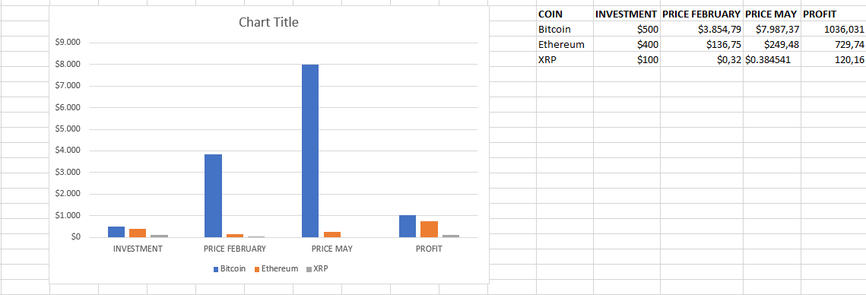

*Figure 25.* Profit of the final portfolio

## **Conclusions**

* + 1. **Comparison of alternative portfolios with the evolution of the cryptocurrency market at the end of May 2019.**

Taking into account the low percentage of return obtained with the final portfolio, due to the investment in XRP, and the narrow budget, the result of some alternative portfolios mentioned in chapter 2 will be evaluated below.

**Alternative portfolio number 1 (Low risk portfolio)**

* Bitcoin: Investment 50% (500 USD).
* Ethereum: Investment 50% (500 USD).

**Bitcoin**

Price on February 28 – 2019 (Day of purchase): 3854,79 USD[5].

Price on May 24 – 2019 (Day of evaluation): 7987,37 USD[5].

Money invested: 500 USD.

Amount of Bitcoin purchased: 0,129 BTC.

Value of Bitcoin purchased on May 24 2019 (After three months): 1030,37 USD.

Return percentage: 106,074%

Profits: 530,37 USD.

**Ethereum**

Price on February 28 – 2019 (Day of purchase): 136,75 USD[5].

Price on May 24 – 2019 (Day of evaluation): 249,48 USD[5].

Money invested: 500 USD.

Amount of Ethereum purchased: 3,656 ETH.

Value of Ethereum purchased on May 24 2019 (After three months): 912,17 USD.

Return percentage: 82,434%

Profits: 412,17 USD.

**Total Profits of Portfolio:** Profits BTC + Profits ETH

(530,37 + 412,17) USD = 942,54 USD

**Total return of Portfolio:** 94,254%

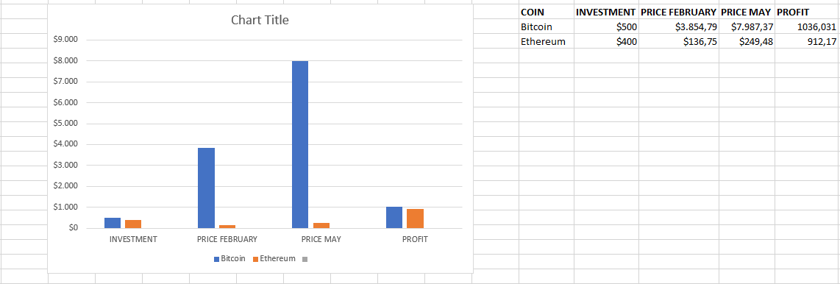

*Figure 26.* Profit of alternative portfolio number 1

**Alternative portfolio number 2 (High risk portfolio)**

* Bitcoin: Investment 50% (500 USD).
* XRP: Investment 10% (100 USD).
* EOS: Investment 40% (400 USD).

**Bitcoin**

Price on February 28 – 2019 (Day of purchase): 3854,79 USD[5].

Price on May 24 – 2019 (Day of evaluation): 7987,37 USD[5].

Money invested: 500 USD.

Amount of Bitcoin purchased: 0,129 BTC.

Value of Bitcoin purchased on May 24 2019 (After three months): 1030,37 USD. Return percentage: 106,074%

Profits: 530,37 USD.

**XRP**

Price on February 28 – 2019 (Day of purchase): 0,315078 USD[5].

Price on May 24 – 2019 (Day of evaluation): 0,384541 USD[5].

Money invested: 100 USD.

Amount of XRP purchased: 316,676 XRP.

Value of Ethereum purchased on May 24 2019 (After three months): 121.77 USD.

Return percentage: 21,77%

Profits: 21,77 USD.

**EOS**

Price on February 28 – 2019 (Day of purchase): 3,54 USD[5].

Price on May 24 – 2019 (Day of evaluation): 6,40 USD[5].

Money invested: 400 USD.

Amount of EOS purchased: 112,994 EOS

Value of Ethereum purchased on May 24 2019 (After three months): 723,16 USD.

Return percentage: 80,79%

Profits: 323,16 USD.

**Total Profits of Portfolio:** Profits BTC + Profits XRP + Profits EOS

(530.37 + 21.77 + 323.16)USD = 875,3 USD

**Total return of Portfolio:** 87,53%

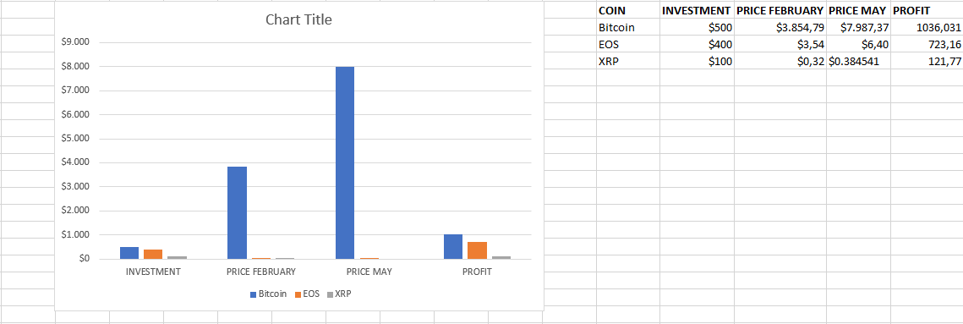

*Figure 27.* Profit of alternative portfolio number 2

**Alternative portfolio number 3 (Highly diversified portfolio)**

* Bitcoin: Investment 25% (2500 USD).
* Ethereum: Investment 25% (250 USD).
* XRP: Investment 25% (250 USD).
* EOS: Investment 25% (250 USD).

**Bitcoin**

Price on February 28 – 2019 (Day of purchase): 3854,79 USD[5].

Price on May 24 – 2019 (Day of evaluation): 7987,37 USD[5].

Money invested: 250 USD.

Amount of Bitcoin purchased: 0,0649 BTC.

Value of Bitcoin purchased on May 24 2019 (After three months): 518,01 USD.

Return percentage: 107.204%

Profits: 268,01 USD.

**Ethereum**

Price on February 28 – 2019 (Day of purchase): 136,75 USD[5].

Price on May 24 – 2019 (Day of evaluation): 249,48 USD[5].

Money invested: 250 USD.

Amount of Ethereum purchased: 1,828 ETH.

Value of Ethereum purchased on May 24 2019 (After three months): 456,08 USD.

Return percentage: 82,432%

Profits: 206,08 USD.

**XRP**

Price on February 28 – 2019 (Day of purchase): 0,315078 USD[5].

Price on May 24 – 2019 (Day of evaluation): 0,384541 USD[5].

Money invested: 250 USD.

Amount of XRP purchased: 804,427 XRP.

Value of Ethereum purchased on May 24 2019 (After three months): 309,33 USD.

Return percentage: 23,732%

Profits: 59,33 USD.

**EOS**

Price on February 28 – 2019 (Day of purchase): 3,54 USD[5].

Price on May 24 – 2019 (Day of evaluation): 6,40 USD[5].

Money invested: 250 USD.

Amount of EOS purchased: 70,621 EOS

Value of Ethereum purchased on May 24 2019 (After three months): 451,977 USD.

Return percentage: 80,7908%

Profits: 201,977 USD.

**Total Profits of Portfolio:** Profits BTC + Profits ETH + Profits XRP + Profits EOS

(268,01 + 206,08 + 59,33 + 201,977) USD = 735,397 USD

**Total return of Portfolio:** 73,5397%

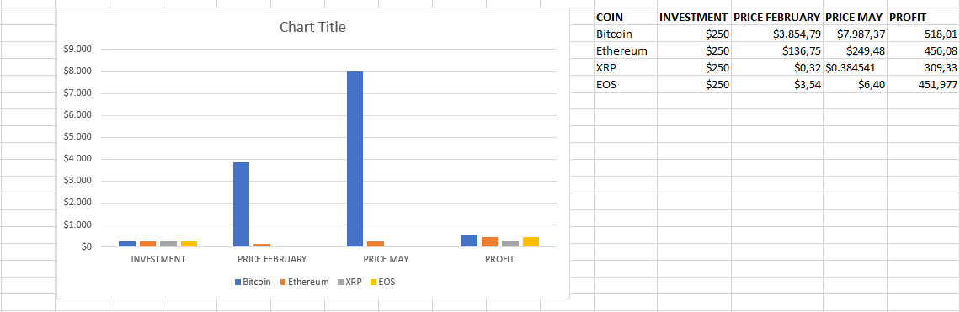

*Figure 28.* Profit of alternative portfolio number 2

* + 1. **Final conclusions**

The result of the selected final portfolio demonstrates the hypothesis that the investment in Bitcoin, XRP and Ethereum is considered as a profitable investment during the year 2019, allowing to always obtain profits, regardless of the selected investment portfolio.

The final portfolio selected, would allow a return of 88.188%, which is quite high for the first half of the year 2019 and augurs a good promise of investment for the rest of the year.

The analysis of the alternative portfolio number 1, allows to observe that in this type of investment, a low diversification and an investment in the two most important cryptocurrency, is the best selection so far in 2019. This result is consistent with the result of the fundamental and technical analysis and a portfolio distributed equally between Bitcoin and Ethereum would allow a return of 94.254%. With a narrow budget, it is better not to diversify the portfolio too much and diversifying the portfolio with only two cryptocurrencies, the benefit may be higher.

The analysis of the alternative portfolio number 2, also shows that a portfolio that includes EOS, can be profitable, although to obtain greater benefits, it would be necessary to invest a greater amount of money. This portfolio would allow a return of 87,53%.

The analysis of the alternative portfolio number 3, which is a highly diversified portfolio (4 different crypto currencies), allows us to observe the lowest rate of return among all the portfolios 73,5397%. This shows that if the budget is reduced, the best option is not to diversify the portfolio too much to maximize profits.

Both the fundamental analysis and the technical analysis allowed to obtain similar deductions regarded to the best investment alternatives, but the technical analysis allowed to analyze in a more approximate way the risk implied in each one of the investments, and the amount of money that should be allocated to each one of the cryptocurrencies.

The cryptocurrency market during the first half of the year 2019, is in an upward trend since February 2019 and taking into consideration the analysis of the charts, it is possible that the major cryptocurrency, especially Bitcoin could reach exceptional prices at the end of the year.

It is possible to identify a pattern in this class of low budget investments in cryptocurrency. The greater the diversification, the lower the return of the portfolio.

* + 1. **Recommendations for small investors**
* The Bitcoin is considered today (ten years after its creation), as one of the most reliable investments that can exist. As mentioned in chapter two, Bitcoin at this time is considered a currency stronger than the US dollar and gold and therefore it is highly advisable to invest.
* It is recommended not to invest a large amount of money when the small investor wants to start with the investment in cryptocurrency. Especially if it is a novice investor.
* It is necessary to investigate a lot about the regulation of the country in which the investor is located, about the use of the various exchange platforms and about the different platforms that offer virtual wallet services.
* According to an exhaustive personal investigation, the best way to buy Bitcoins in Russia is through the platform www.coinmama.com and the best way to store Bitcoins and other digital currencies is using the platform [www.blockchain.com](http://www.blockchain.com).
* Another way to buy Bitcoins and other digital currencies in Russia, is through the platform www.localbitcoins.com, in which it is possible to contact private sellers, but unfortunately this platform is sadly famous for the large number of scams of which customers have been targeted.
* There are other Bitcoins storage services such as the platform www.binance.com, but unfortunately this and other platforms have been attacked several times by hackers. In the first week of May 2019, the Binance platform was hacked and 7000 Bitcoins equivalent to 48 million dollars were stolen from the platform[62].
* Some investors resort to installing virtual wallet software on their computers, but if the equipment is manipulated by third parties or has a history of internet access to sites of unknown origin, it is not recommended to store cryptocurrency in this type of equipment, because they can be easily hacked and the investor will lose all their money.
* It is considered a good investment practice, when the investor starts in the world of cryptocurrency, initially invest in Bitcoin and then as the price rises, trade with the profits and buy other cryptocurrency of lower value (Ethereum, EOS) and with great promise of benefit in the future.
* The best way to make money with Bitcoin is to trade in the interspersed points of rise and fall, possibly daily and not wait for the big peaks of rise to sell.
  + 1. **Final considerations - the future of Bitcoin and cryptocurrencies**
* According to multiple experts (Max Keiser, Steve Wozniak from Apple), the future of Bitcoin is to become a reserve world currency, displacing the dollar from this privileged position it has held for years[63]. The only factor that is making the dollar seem to reach record highs at the end of May 2019 is the open trade war with China and the sanctions imposed on major Chinese companies (Huawei Technologies).
* It is possible that the Bitcoin reaches within two years, a price above $ 100,000 and when this happens, it may end up destroying not only the dollar and other Fiat currencies, but also the other cryptocurrency available in the market[64], and this factor, added to other factor as the limited supply of Bitcoins, and the incorruptibility of the blockchain system, allow to assume that Bitcoin is a powerful, stable currency and that investing in Bitcoin is a very good decision.
* Nobody will be able to stop Bitcoin, because nobody can stop mathematics, computer science and creativity. At the beginning of the 2000s, the record companies started a legal war against Napster and other systems to download music on Internet, and in the end the record stores ended up going bankrupt worldwide. Nowadays, the whole entire world downloads music over the internet in MP3 and other compressed formats. The same happened with bankruptcy worldwide of transnational companies dedicated to the rental of movies, such as Blockbuster and unfortunately the same happened with bookstores. At the end of the second decade of the XXI century almost everyone, watch movies online and download books for free from Internet. As it has happened with all the new inventions that involve the digital revolution, Bitcoin will continue, and will continue to be supported a worldwide community who believes in financial freedom, who is tired from government regulation and surveillance and will end up replacing traditional money and traditional financial institutions in all over the world.
* At the beginning of April 2019, a new upward trend began and according to the observation of past trends, this trend could end with a new historical maximum at the end of 2019. By the end of May, the price exceeds 8700 USD and it is possible to observe small corrections and then, a continuation with the upward trend (see Figure 29).

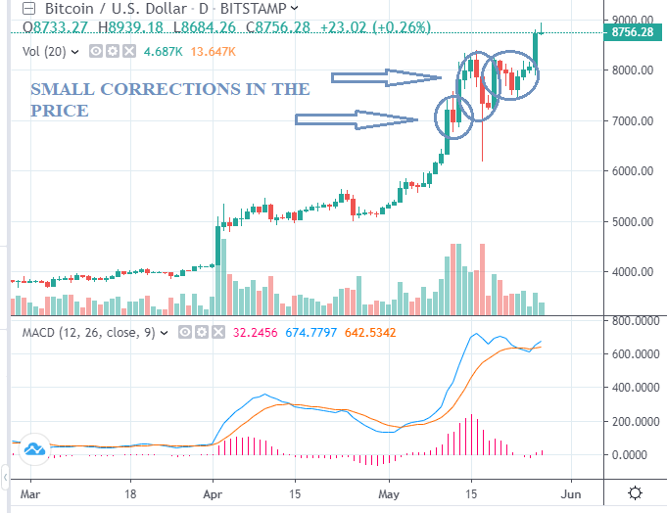

*Figure 29.* Upward trend, price and corrections at the end of May 2019 [Adapted from 65].

- The last time an upward trend similar to May 2019 was observed was in April 2017 and the trend continued until reaching the exorbitant sum of USD 20000 in December of that year. The charts show that it is advisable to invest in Bitcoin during 2019, because it will probably be the last time it will be possible to acquire this currency for a price lower than $ 10,000. As mentioned in chapter two, according to the observation of the graphs, whenever the Bitcoin is in a prolonged upward trend, the price rises to spectacular levels, to then stabilize at a higher price than the last time an upward trend occurred. Therefore, it is considered that at the end of May there is a great opportunity to obtain considerable benefits if at least 1000 dollars are allocated to the investment in cryptocurrency (see Figure 30).

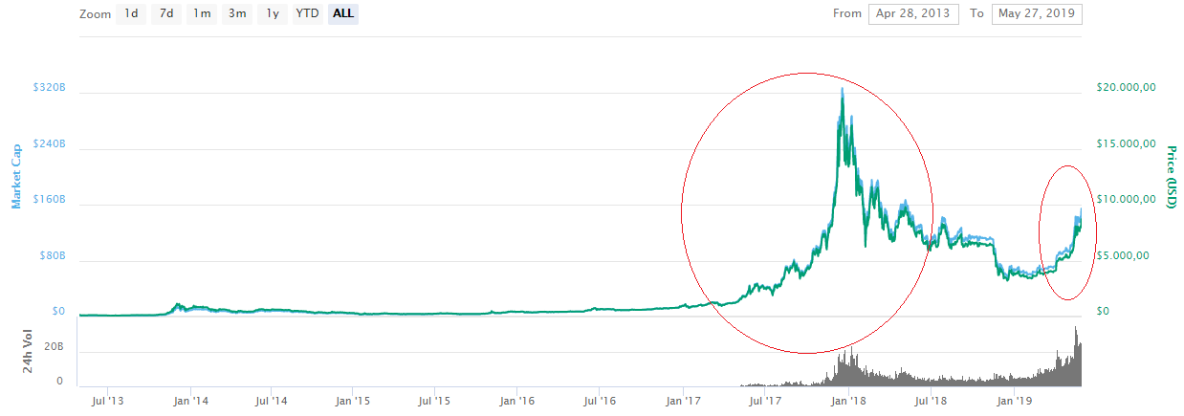

*Figure 30.* Bitcoin bullish trends [Adapted from 5].

**Appendix A Top 10 of Digital Currencies during the year 2018**

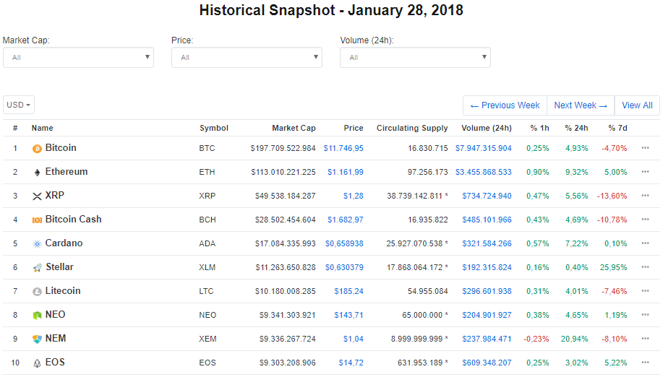

*Figure A1.* Ranking of the most important cryptocurrencies at the end of January 2018 [Adapted from 5]

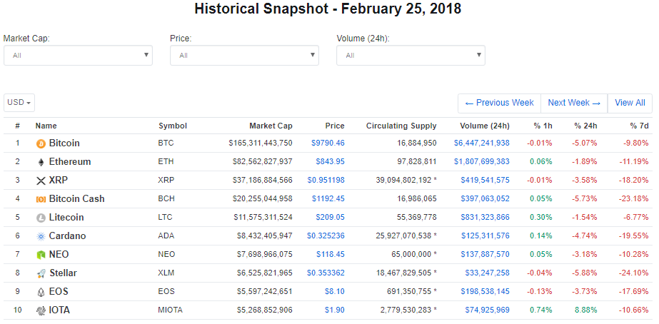

*Figure A2.* Ranking of the most important cryptocurrencies at the end of February 2018 [Adapted from 5]

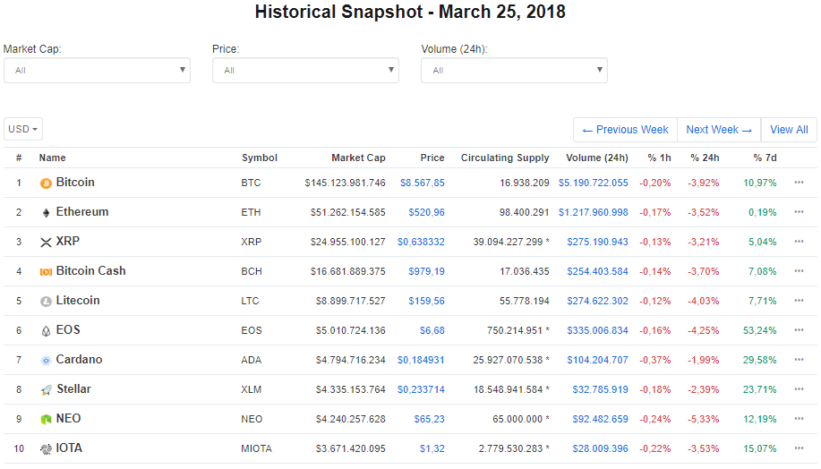

*Figure A3.* Ranking of the most important cryptocurrencies at the end of March 2018 [Adapted from 5]

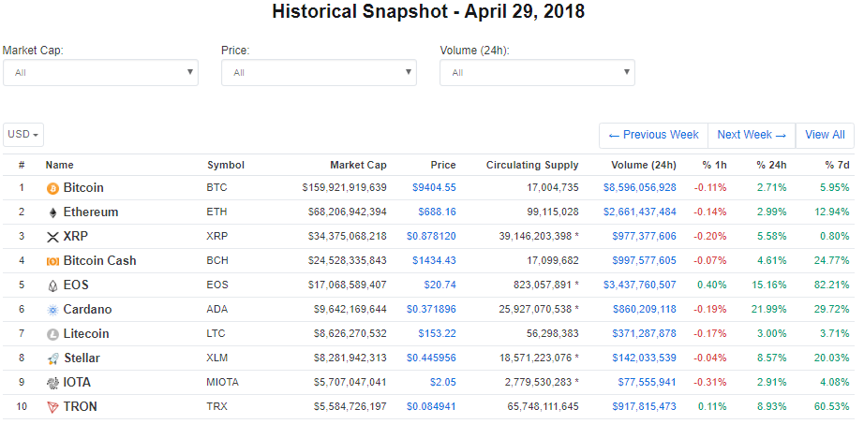

*Figure A4.* Ranking of the most important cryptocurrencies at the end of April 2018 [Adapted from 5]

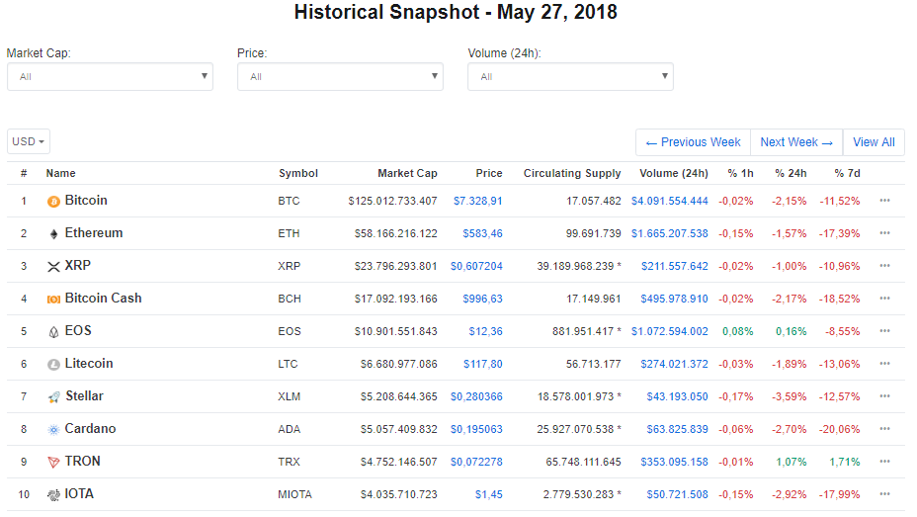

*Figure A5.* Ranking of the most important cryptocurrencies at the end of May 2018 [Adapted from 5]

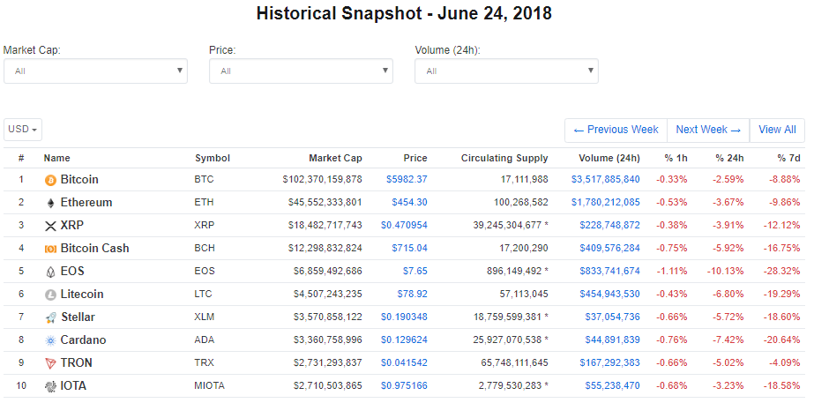

*Figure A6.* Ranking of the most important cryptocurrencies at the end of June 2018 [Adapted from 5]

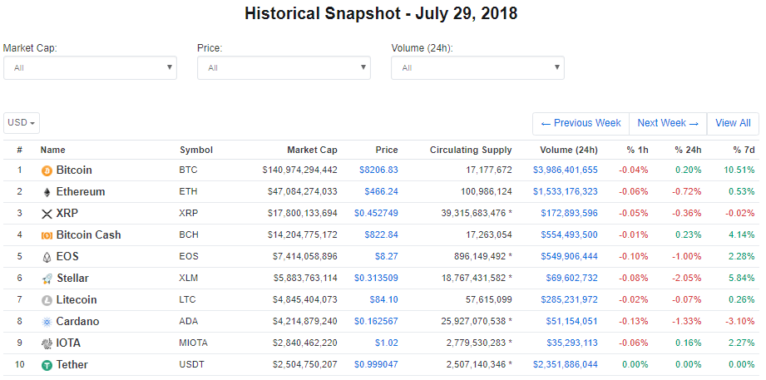

*Figure A7.* Ranking of the most important cryptocurrencies at the end of July 2018 [Adapted from 5]

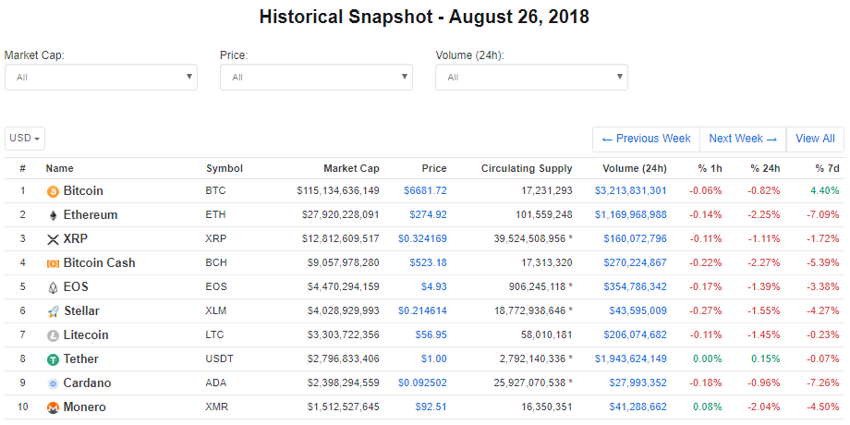

*Figure A8.* Ranking of the most important cryptocurrencies at the end of August 2018 [Adapted from 5]

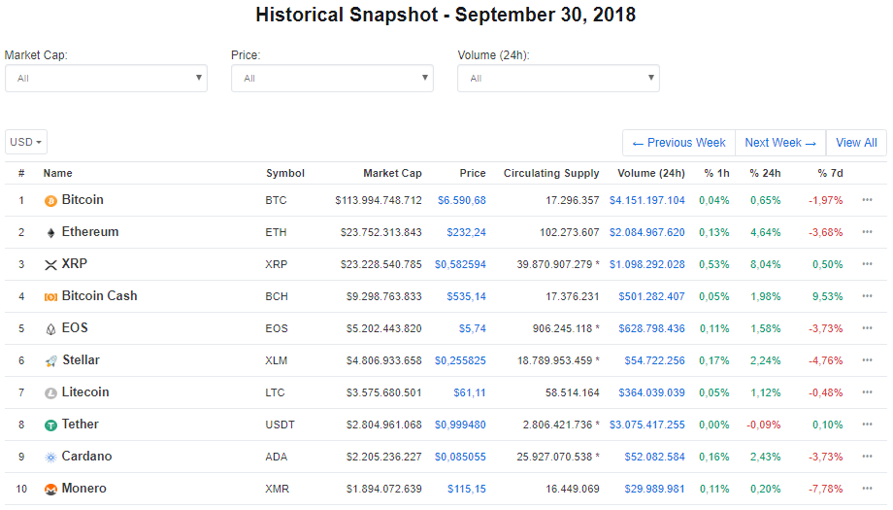

*Figure A9.* Ranking of the most important cryptocurrencies at the end of September 2018 [Adapted from 5]

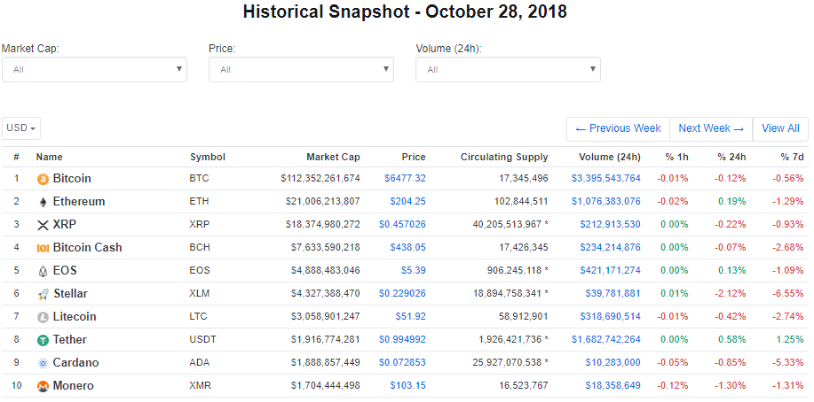

*Figure A10.* Ranking of the most important cryptocurrencies at the end of October 2018 [Adapted from 5]

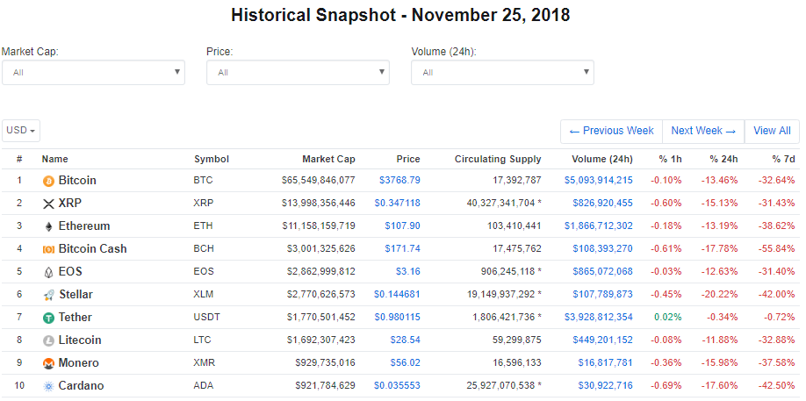

*Figure A11.* Ranking of the most important cryptocurrencies at the end of November 2018 [Adapted from 5]

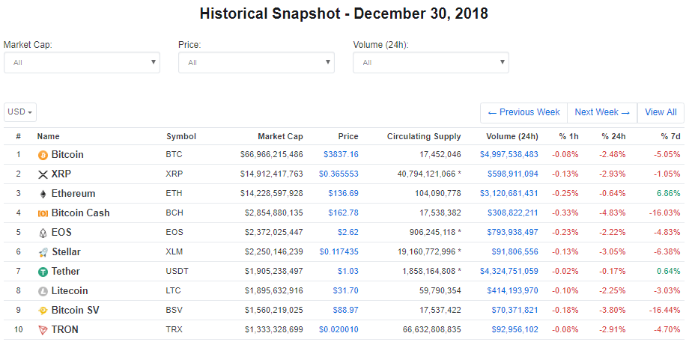

*Figure A12.* Ranking of the most important cryptocurrencies at the end of December 2018 [Adapted from 5]

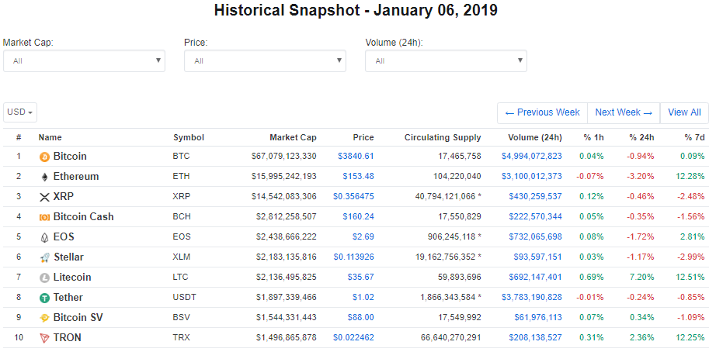

*Figure A13.* Ranking of the most important cryptocurrencies at the beginning of January 2019 [Adapted from 5]

# **Appendix B Ranking and trends of USD Coin and TrueUSD by Market Capitalization**

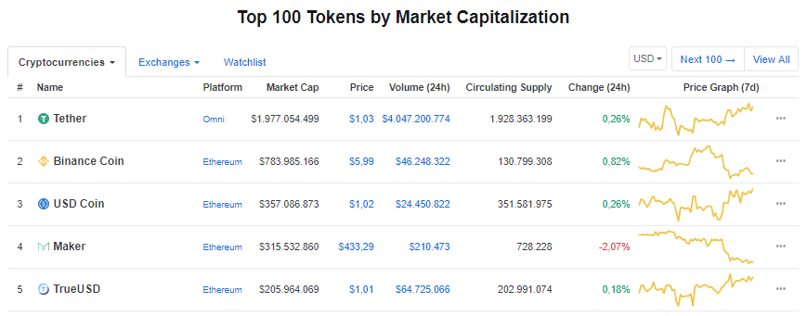

*Figure B1*. Ranking of USD Coin and TrueUSD on the Market Capitalization of Tokens on January 2019 [Adapted from 5]

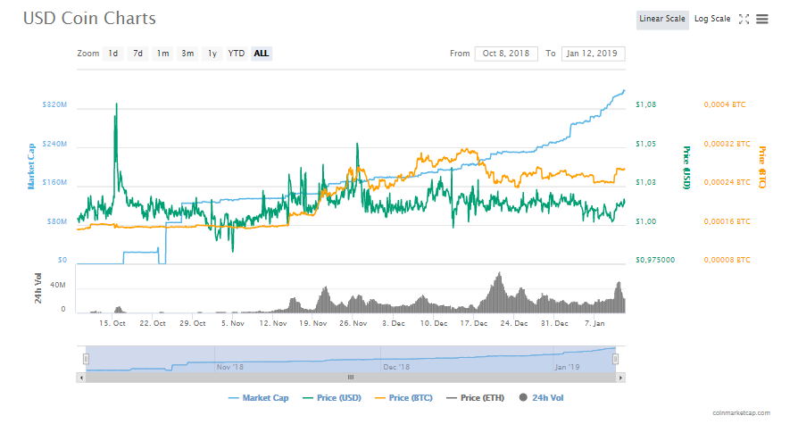

*Figure B2.* Evolution in the trend from October 2018 to January 2019 of USD Coin [Adapted from 5]

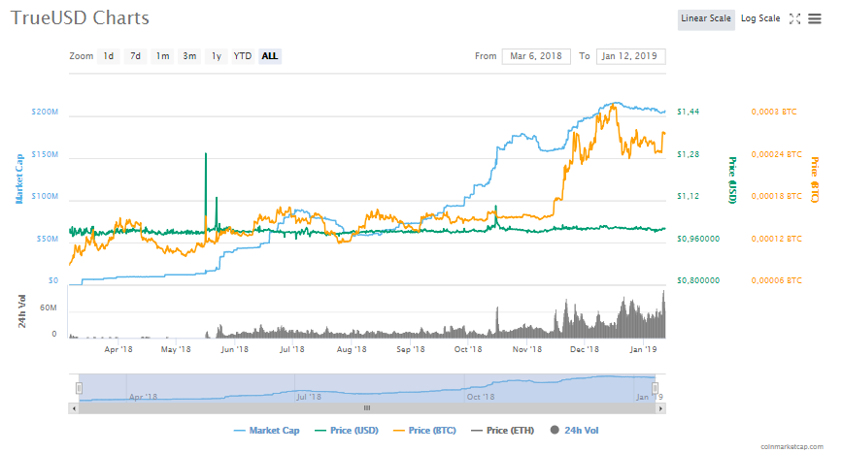

*Figure B3.* Evolution in the trend from April 2018 to January 2019 of TrueUSD [Adapted from 5]

# **Appendix C Information of Digital Currencies and Tokens used in the project**

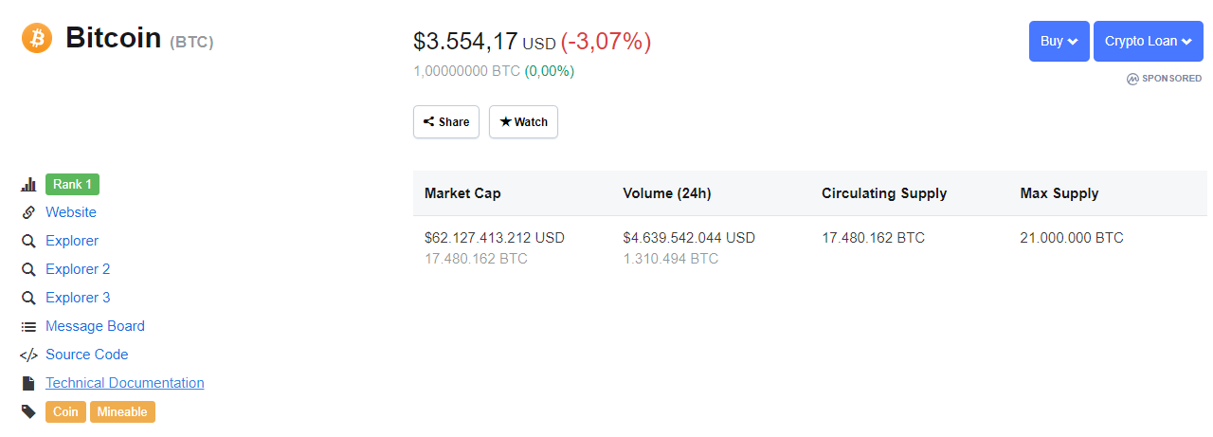

*Figure C1.* Financial information of Bitcoin (February 2019). [Adapted from 5]

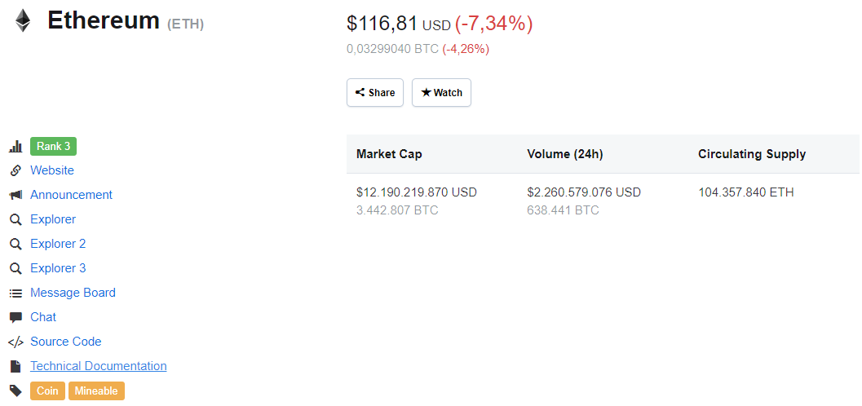

*Figure C2.* Financial information of Ethereum (February 2019). [Adapted from 5]

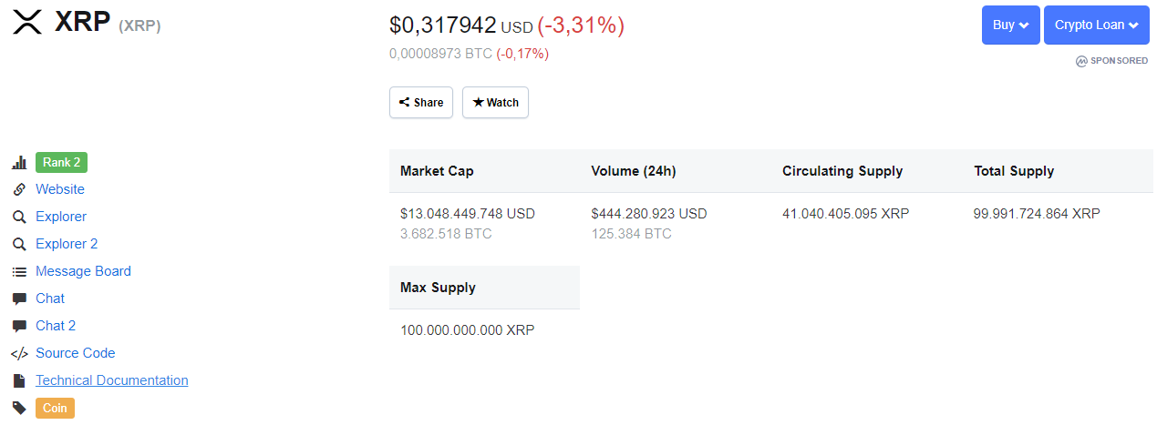

*Figure C3.* Financial information of Ripple (February 2019). [Adapted from 5]

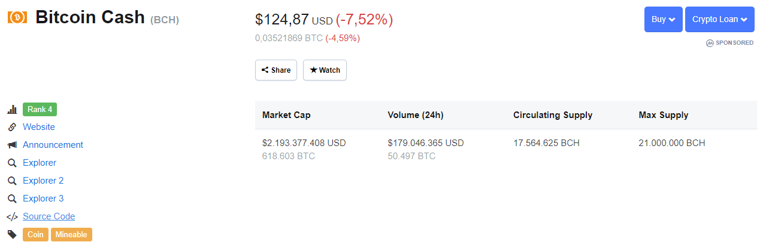

*Figure C4.* Financial information of Bit.Cash (February 2019). [Adapted from 5]

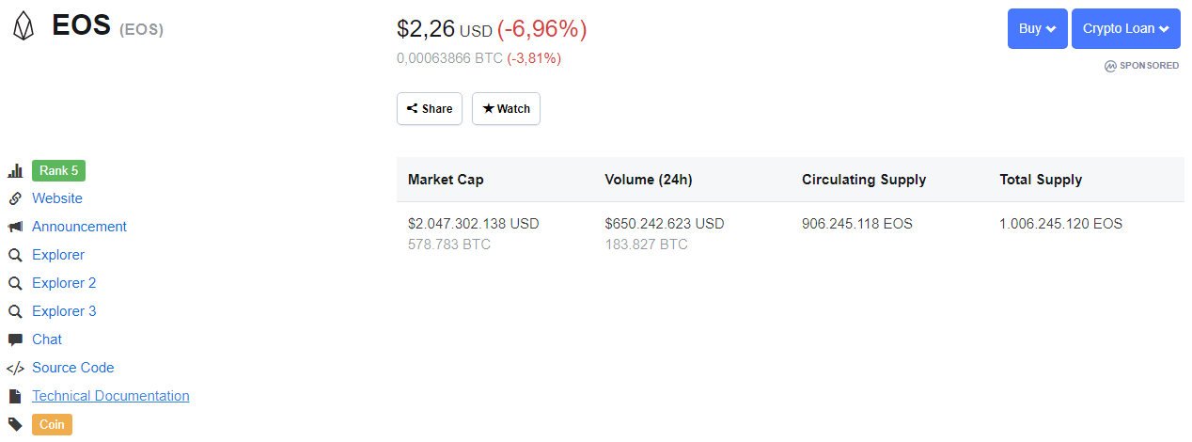

*Figure C5.* Financial information of EOS (February 2019). [Adapted from 5]

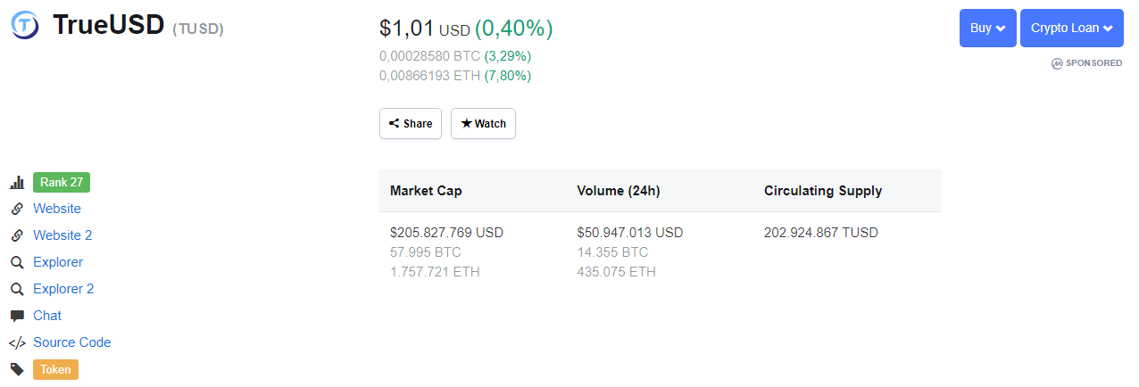

*Figure C6.* Financial information of TrueUSD (February 2019). [Adapted from 5]

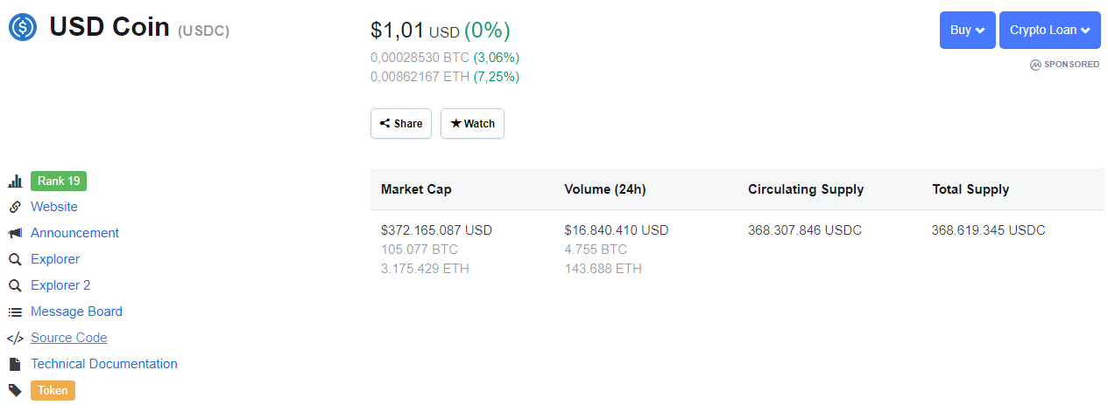

*Figure C7.* Financial information of USD Coin (February 2019). [Adapted from 5]

# **Appendix D List of resources used for Stage 3 of Fundamental Analysis**

|  |  |  |  |
| --- | --- | --- | --- |
| **COIN** | **DEMAND, SUPPLY, INSTABILITY, BEAR/BULL MARKETS** | **PERCEPTION** | **INVESTORS** |
| Bitcoin | [www.coinmarketcap.com](http://www.coinmarketcap.com) | <https://www.researchgate.net/publication/316656878_An_Analysis_of_Cryptocurrency_Bitcoin_and_the_Future> | <https://www.investopedia.com/articles/people/091516/top-5-investors-investing-bitcoin.asp> |
| Ether | [www.coinmarketcap.com](http://www.coinmarketcap.com) | <https://medium.com/the-mission/ethereum-price-trends-2018-predictions-9710b4fa4024> | <https://usethebitcoin.com/list-of-famous-ethereum-investors/> |
| XRP | [www.coinmarketcap.com](http://www.coinmarketcap.com) | <https://medium.com/the-mission/ethereum-price-trends-2018-predictions-9710b4fa4024> | <https://globalcoinreport.com/heres-why-warren-buffett-is-already-invested-in-ripple-xrp/> |
| Bt. Cash | [www.coinmarketcap.com](http://www.coinmarketcap.com) | <https://cointelegraph.com/bitcoin-cash-for-beginners/what-is-bitcoin-cash#where-can-i-store-bitcoin-cash> | <https://www.newsbtc.com/2018/08/28/roger-ver-bitcoin-cash-is-a-better-investment-than-bitcoin/> |
| EOS | [www.coinmarketcap.com](http://www.coinmarketcap.com) | <https://coinswitch.co/info/eos/what-is-eos> | <https://www.ccn.com/12-billion-bitmains-second-major-investment-in-2018-is-eos/> |
| TrueUSD | [www.coinmarketcap.com](http://www.coinmarketcap.com) | <https://coincheckup.com/coins/true-usd/markets> | <https://bitcoinexchangeguide.com/andreessen-horowitz-a16z-invests-20-million-into-trusttoken-trueusd-stablecoin/> |
| USDCoin | [www.coinmarketcap.com](http://www.coinmarketcap.com) | <https://www.bitrates.com/news/p/circle-breaks-into-stablecoins-by-launching-usd-coin> | <https://bitcoinexchangeguide.com/coinbase-backed-stablecoin-from-circle-usd-coin-issues-over-125-million-in-investments/> |

*Table D1.* List of resources used for Stage 3 of Fundamental Analysis

# **Appendix E Preliminary Portfolios (According to Fundamental Analysis)**

**Portfolio 1 (February 29 2019):**

**Criteria to choose the portfolio:**

Budget: 1000 USD.

Diversification:

* Bitcoin.
* XRP.
* Ethereum.

According to fundamental analysis, the three cryptocurrencies have different projects related to them.

Characteristics of the selected coins:

- Bitcoin (more stable in comparison with XRP and Ethereum, Bitcoin is the more important cryptocurrency). ROI (measured since the date that the coin was released) 5.767,37% [5]. Price (3871,65 USD on February 28 2019)

- XRP (Biggest growth in capitalization market). ROI 6.778,66% (measured since the date that the coin was released)[5] Price (0,21 USD on February 28 2019).

- Ethereum (Biggest return on investment). ROI 8.880,09% (measured since the date that the coin was released)[5] Price (137,99 USD on February 29 2019).

Assets allocation:

* Bitcoin: Investment 50% (500 USD).
* XRP: Investment 25% (250 USD).
* Ethereum: Investment 25% (250 USD).

Criteria:

* Bitcoin is the most important cryptocurrency, and it’s advisable to invest at least the half of the investment budget on Bitcoin.
* XRP and Ethereum are promising projects. It is considered advisable to divide the other half of the money on XRP and Ethereum.
* The price of XRP is very low and it’s possible to buy 1.190,476 coins with 250 USD. Taking into consideration the return of investment of this coin, it is considered an advisable investment.

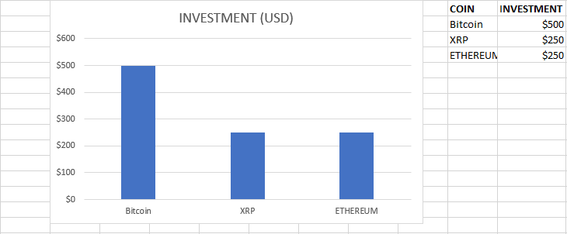

*Figure E1.* Portfolio 1

**Portfolio 2 (February 29 2019):**

**Criteria to choose the portfolio:**

Budget: 1000 USD.

Diversification:

* Bitcoin.
* XRP.
* EOS.

According to fundamental analysis, he three cryptocurrencies have different projects related to them, and EOS has characteristics similar to Ethereum, which is why it is considered an alternative to the investment in Ethereum.

Characteristics of the selected coins.

- Bitcoin (more stable in comparison with XRP and Ethereum, Bitcoin is the more important cryptocurrency). ROI (measured since the date that the coin was released) 5.767,37% [5]. Price (3871,65 USD on February 28 2019)

- XRP (Biggest growth in capitalization market). ROI 6.778,66% (measured since the date that the coin was released)[5] Price (0,21 USD on February 28 2019).

- EOS (Second position in capitalization market within the final subset of currencies). ROI 511.58% (measured since the date that the coin was released)[5] Price (3,29 USD on February 29 2019).

Assets allocation:

* Bitcoin: Investment 50% (500 USD).
* XRP: Investment 40% (400 USD).
* EOS: Investment 10% (100 USD).

Criteria:

* Bitcoin is the most important cryptocurrency, and it’s advisable to invest at least the half of the investment budget on Bitcoin.
* XRP and EOS are promising projects. Nevertheless, the promise of return of investment of XRP is higher than EOS, it is advisable to invest more money on XRP than EOS.
* The price of XRP is very low and it’s possible to buy 1.904,76 coins with 400 USD. Taking into consideration the return of investment of this coin, it is considered an advisable investment. The price of EOS is low too, and it’s possible to buy 30.39 coins with 100 USD.

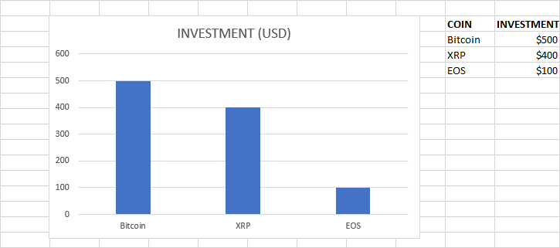

*Figure E2.* Portfolio 2

**Portfolio 3 (February 29 2019):**

**Criteria to choose the portfolio:**

Budget: 1000 USD.

Diversification:

* Bitcoin.
* Ethereum.

According to fundamental analysis, both cryptocurrencies have different projects related to them. Ethereum has a very reliable blockchain system and although the price of the coin is relatively high, the return on investment is very high too.

Characteristics of the selected coins.

- Bitcoin (more stable in comparison with XRP and Ethereum, Bitcoin is the more important cryptocurrency). ROI (measured since the date that the coin was released) 5.767,37% [5]. Price (3871,65 USD on February 28 2019).

- Ethereum (Biggest return on investment). ROI 8.880,09% (measured since the date that the coin was released)[5] Price (137,99 USD on February 29 2019).

Assets allocation:

* Bitcoin: Investment 50% (500 USD).
* Ethereum: Investment 50% (500 USD).

Criteria:

* Bitcoin is the most important cryptocurrency, and it’s advisable to invest at least the half of the investment budget on Bitcoin.
* The price of Bitcoin is very high and with 500 USD it’s only possible to buy 0,12916 Bitcoin (In the cryptocurrency market it’s possible to purchase subdivisions of Bitcoin known as Satoshis). Ethereum is more affordable and its project is promising. The price allows the investor to get at least 3.6234 units with 500 USD.

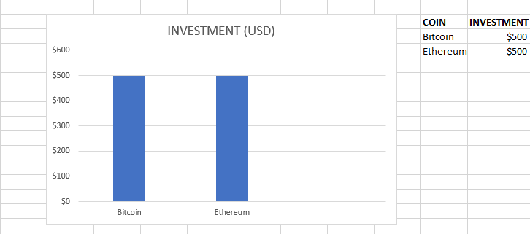

*Figure E3.* Portfolio 3

# **Appendix F Candlesticks Charts**

**Bitcoin (February 2019)**

*Figure F.1* Bitcoin Price February 2019

**XRP (February 2019)**

*Figure F2.* XRP Price February 2019

**Ethereum (February 2019)**

*Figure F3.* Ethereum Price (February 2019)

**Bitcoin Cash (February 2019)**

*Figure F.4* Bitcoin Cash Price (February 2019)

**EOS (February 2019)**

*Figure F.5* EOS Price (February 2019)

# **Appendix G Preliminary Portfolios (According to Technical Analysis)**

**Portfolio 1 (February 29 2019):**

**Criteria to choose the portfolio:**

Budget: 1000 USD.

Diversification:

* Bitcoin.
* Ethereum.
* EOS.

According to technical analysis, the three cryptocurrencies represent the most advisable investments.

Characteristics of the selected coins:

- Bitcoin (more stable in comparison with EOS and Ethereum, Bitcoin is the more important cryptocurrency). ROI (measured since the date that the coin was released) 5.767,37% [5]. Price (3871,65 USD on February 28 2019)

- Ethereum (Biggest return on investment). ROI 8.880,09% (measured since the date that the coin was released)[5] Price (137,99 USD on February 29 2019).

- EOS (Second position in capitalization market within the final subset of currencies). ROI 511.58% (measured since the date that the coin was released)[5] Price (3,29 USD on February 29 2019).

Assets allocation:

* Bitcoin: Investment 50% (500 USD).
* Ethereum: Investment 25% (250 USD).
* EOS: Investment 25% (250 USD).

Criteria:

* Bitcoin is the most important cryptocurrency, and it’s advisable to invest at least the half of the investment budget on Bitcoin because it represents a safe investment.
* Ethereum and EOS are the most advisable investments according to indexes analysis. It is considered advisable to divide the other half of the money on Ethereum and EOS.
* EOS is the best option to diversify the portfolio due to its low covariance and volatility index related to Bitcoin. Its low price allows the investor to buy a considerable amount of coins.

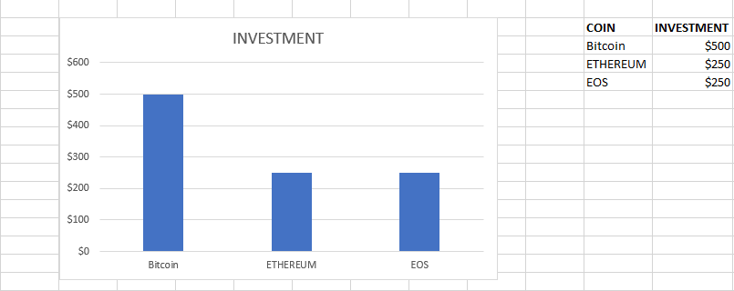

*Figure G1.* Portfolio 1

**Portfolio 2 (February 29 2019):**

**Criteria to choose the portfolio:**

Budget: 1000 USD.

Diversification:

* Bitcoin.
* XRP.
* EOS.

According to technical analysis, this portfolio is a risky portfolio, because XRP and EOS represent investments that involve high risk but high possibilities of return at the same time.

Characteristics of the selected coins.

- Bitcoin (more stable in comparison with XRP and Ethereum, Bitcoin is the more important cryptocurrency). ROI (measured since the date that the coin was released) 5.767,37% [5]. Price (3871,65 USD on February 28 2019)

- XRP (Biggest growth in capitalization market). ROI 6.778,66% (measured since the date that the coin was released)[5] Price (0,21 USD on February 28 2019).

- EOS (Second position in capitalization market within the final subset of currencies). ROI 511.58% (measured since the date that the coin was released)[5] Price (3,29 USD on February 29 2019).

Assets allocation:

* Bitcoin: Investment 50% (500 USD).
* XRP: Investment 10% (100 USD).
* EOS: Investment 40% (400 USD).

Criteria:

* Bitcoin is the most important cryptocurrency, and it’s advisable to invest at least the half of the investment budget on Bitcoin, because it represents a safe investment, specially if the portfolio is diversified with very risky investments.
* XRP and EOS are very profitable investments, but a higher percentage of the budget should be allocated on EOS, according to the index’s analysis.
* The price of XRP is very low and it’s possible to buy 476,19 coins with 100 USD. Taking into consideration the return of investment of this coin, it is considered an advisable investment. The price of EOS is low too, and it’s possible to buy 121,58 coins with 400 USD.

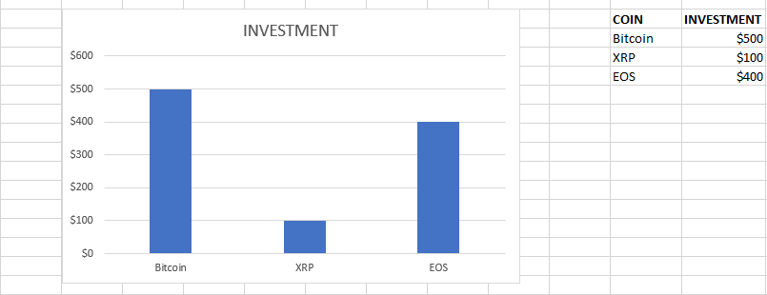

*Figure G2.* Portfolio 2

**Portfolio 3 (February 29 2019):**

**Criteria to choose the portfolio:**

Budget: 1000 USD.

Diversification:

* Bitcoin.
* Ethereum.
* XRP.

According to technical analysis, this portfolio involves an intermediate level of risk because Ethereum represent an intermediate point of risk and XRP represents an investment that involves high risk but high possibilities of return at the same time.

Characteristics of the selected coins.

- Bitcoin (more stable in comparison with XRP and Ethereum, Bitcoin is the more important cryptocurrency). ROI (measured since the date that the coin was released) 5.767,37% [5]. Price (3871,65 USD on February 28 2019).

- Ethereum (Biggest return on investment). ROI 8.880,09% (measured since the date that the coin was released)[5] Price (137,99 USD on February 29 2019).

- XRP (Biggest growth in capitalization market). ROI 6.778,66% (measured since the date that the coin was released)[5] Price (0,21 USD on February 28 2019).

Assets allocation:

* Bitcoin: Investment 50% (500 USD).
* Ethereum: Investment 20% (200 USD).
* XRP: Investment 30% (300 USD).

Criteria:

* Bitcoin is the most important cryptocurrency, and it’s advisable to invest at least the half of the investment budget on Bitcoin, because it represents a safe investment, specially if the portfolio is diversified with very risky investments.
* Ethereum offers the biggest return on investment, but the price is very high. For this reason taking into consideration the narrow budget, more money will be allocated to invest in XRP.
* The price of XRP is very low and it’s possible to buy 476,19 coins with 100 USD. Taking into consideration the return of investment of this coin, it is considered an advisable investment.

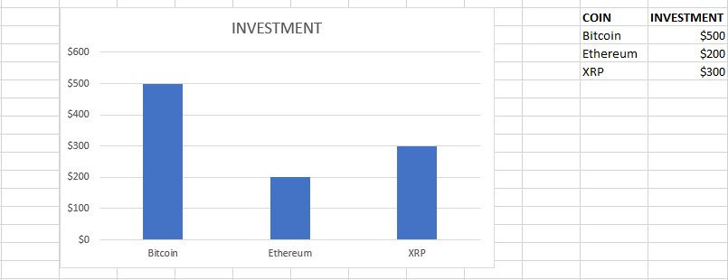

*Figure G3.* Portfolio 3

# **Bibliography**

1. How is Bitcoin Money? - Ole Bjerg, 2016. (2019). Retrieved from <https://journals.sagepub.com/doi/abs/10.1177/0263276415619015>.
2. How Can Cryptocurrency and Blockchain Technology Play a Role in Building Social and Solidarity Finance? | Events | UNRISD. (2019). Retrieved from <http://www.unrisd.org/brett-scott>.
3. Cryptocurrency Bitcoin: Disruption, challenges and opportunities: Ingenta Connect. (2019). Retrieved from <https://www.ingentaconnect.com/content/hsp/jpss/2015/00000009/00000001/art00005>.
4. Chaussée, S. (2002). Advanced portfolio management. Jersey City, NJ (P.O. Box 8358, NJ 07308)): Palisade Business Press.
5. CoinMarketCap. (2018). *Cryptocurrency Market Capitalizations | CoinMarketCap*. [online] Available at: https://coinmarketcap.com/ [Accessed 7 Dec. 2018].
6. Forbes. (2018). *Business Magazine* | *Forbes.* [online] Available at: <https://www.forbes.com/sites/naeemaslam/2018/12/19/will-ripples-xrp-thrive-in-2019/#22e5d96f4910> [Accessed 19 Dec. 2018].
7. Harvard Business Review. (2019). *The Truth About Blockchain.* [online] Available at: <https://hbr.org/2017/01/the-truth-about-blockchain> [Accessed 12 Jan. 2019].
8. The economist. (2019). *The great chain of being sure about things.* [online] Available at: <https://www.economist.com/briefing/2015/10/31/the-great-chain-of-being-sure-about-things> [Accessed 12 Jan. 2019].
9. Groetsema, A., Groetsema, A., Sahdev, N., Salami, N., Schwentker, R., Grabovetsky A., Paoli N., Curran S. (2019). Blockchain for Business: An Introduction to Hyperledger Technologies [The Linux Foundation MOOC]. Available at: <https://courses.edx.org/courses/course-v1:LinuxFoundationX+LFS171x+3T2018/course/> (date of consultation: 15.11.2018).
10. Kelly A. The Complete Step by Step Guide to Cryptocurrency Trading & Investing “CryptoMeister.io”, 2017. – Available at: <https://www.udemy.com/cryptomeister-introductory-course-in-cryptocurrency-trading-investing/>
11. Santos, R., Bennett, C., Lee, E., Callender, E., Davis, D. (2018). Blockchain: Understanding Its Uses and Implications [The Linux Foundation MOOC]. Available at:<https://courses.edx.org/courses/course-v1:LinuxFoundationX+LFS170x+2T2018/course/> (date of consultation: 15.11.2018).
12. Activism.net. (2018). *A Cypherpunk's Manifesto*. [online] Available at: https://www.activism.net/cypherpunk/manifesto.html [Accessed 6 Dec. 2018].
13. Chohan, Usman W., Cryptoanarchism and Cryptocurrencies (November 27, 2017). Available at SSRN: <https://ssrn.com/abstract=3079241> [Accessed 7 Dec. 2018].
14. Libertarianism.org. (2018). *The Dream of the ’90s is Alive In Cryptocurrencies*. [online] Available at: https://www.libertarianism.org/columns/dream-90s-is-alive-cryptocurrencies [Accessed 6 Dec. 2018].
15. Bitcoin.org. (2018). [online] Available at: https://bitcoin.org/bitcoin.pdf [Accessed 7 Dec. 2018].
16. Forbes.com. (2018). *A Short History Of Bitcoin And Crypto Currency Everyone Should Read*. [online] Available at: <https://www.forbes.com/sites/bernardmarr/2017/12/06/a-short-history-of-bitcoin-and-crypto-currency-everyone-should-read/#32e82e573f27> [Accessed 7 Dec. 2018].
17. Investopedia. (2018). *Crypto Token* [online] Available at: <https://www.investopedia.com/terms/c/crypto-token.asp> [Accessed 8 Dec. 2018].
18. Investopedia. (2018). *Initial Coin Offering* [online] Available at <https://www.investopedia.com/terms/i/initial-coin-offering-ico.asp> [Accessed 8 Dec. 2018].
19. Encyclopedia Britannica. (2018). *Crowdfunding*. [online] Available at: https://www.britannica.com/topic/Crowdfunding-1945925 [Accessed 8 Dec. 2018].
20. Forbes. (2018). *How to Smartly Invest in ICOs and the Risk They Present.* [online] Available at: <https://www.forbes.com/sites/theyec/2018/02/06/how-to-smartly-invest-in-icos-and-the-risks-they-present/#5690adb34b86> [Accessed 1 Jan. 2019].
21. Finder. (2019). *Is bicoin legal? Cryptocurrency regulations around the world.* [online] Available at: <https://www.finder.com/global-cryptocurrency-regulations> [Accessed 10 Jan. 2019].
22. Fobes. (2018). *How to start investing in Cryptocurrency.* [online] Available at: <https://www.forbes.com/sites/forbesfinancecouncil/2018/08/02/how-to-start-investing-in-cryptocurrency/#430115935d75> [Accessed 10 Jan. 2019].
23. Lin, R., Wang, M., Li, D., Akhtar, N., Chintakrindi, S., Savla, R., Zoghb, N., Luo, D., Shen, N., Navani, D. (2018). Bitcoin and Cryptocurrencies [University of California, Berkeley MOOC]. Available at: <https://courses.edx.org/courses/course-v1:BerkeleyX+CS198.1x+3T2018/course/> (date of consultation: 15.11.2018).
24. EOS. (2019). *The most powerful infrastructure for decentralized applications.* [online] Available at: <https://eos.io/> [Accessed 5 Jan. 2019].
25. CoinSwitch. (2019). *What is True USD?.* [online] Available at: <https://coinswitch.co/info/true-usd/what-is-true-usd> [Accessed 8 Jan. 2019].
26. Coindesk. (2019). *USD Coin Arrives: Circle’s Crypto Stablecoin is Now Trading.* [online] Available at: <https://www.coindesk.com/usd-coin-arrives-circles-crypto-stablecoin-is-now-trading> [Accessed 8 Jan. 2019].
27. Chaussée, S. (2002). *Advanced portfolio management*. Jersey City, NJ (P.O. Box 8358, NJ 07308)): Palisade Business Press.
28. Petrov, S. and Kashina, O. (2014). *Advanced Portfolio Management*. 1st ed. Nizhny Novgorod: Lobachevsky State University.
29. Investopedia. (2019). *Portfolio Management.* [online] Available at: <https://www.investopedia.com/terms/p/portfoliomanagement.asp> [Accessed 8 Jan. 2019].
30. Petrov, S., & Kashina, O. (2018). *The basic principles of technical and fundamental analysis*. Lecture, Lobachevsky State University of Nizhny Novgorod.
31. Investopedia. (2018). *Fundamental Analysis.* [online] Available at: <https://www.investopedia.com/terms/f/fundamentalanalysis.asp> [Accessed 8 Jan. 2019].
32. Investopedia. (2018). *Technical Analysis.* [online] Available at: <https://www.investopedia.com/terms/t/technicalanalysis.asp> [Accessed 8 Jan. 2019].
33. Steemit. (2018). *Candlesticks-Las Correcciones del Bitcoin.* [online] Available at: <https://steemit.com/money/@conchita/candlesticks-las-correcciones-del-bitcoin> [Accessed 15 Jan. 2019].
34. Tradingview. (2018). *BTC/USD Fibonacci retracement.* [online] Available at: <https://www.tradingview.com/chart/BTCUSD/e9nYQlF3-BTC-USD-fibonacci-retracement/> [Accessed 8 Jan. 2019].
35. Cryptona.co (2019). *Moving Average Indicators That Bitcoin May Hit $2800 Level.* [online] Available at: <https://cryptona.co/moving-average-indicators-bitcoin-may-hit-2800-level/> [Accessed 15 Jan. 2019].
36. Fidelity (2019). *Relative Strength Index (RSI).* [online] Available at: <https://www.fidelity.com/learning-center/trading-investing/technical-analysis/technical-indicator-guide/RSI> [Accessed 15 Jan. 2019].
37. Maxkeiser.com. (2019). *Max Keiser | Gold, Silver, Bitcoin*. [online] Available at: https://www.maxkeiser.com/ [Accessed 18 May 2019].
38. Bitcoin se ha revalorizado más que el dólar y el oro desde su creación | CriptoNoticias - Bitcoin, blockchains y criptomonedas. (2019). Retrieved from <https://www.criptonoticias.com/mercados/bitcoin-dolar-creacion-oro/>.
39. ¿Qué son los contratos de futuros de Bitcoin? | CriptoNoticias - Bitcoin, blockchains y criptomonedas. (2019). Retrieved from https://www.criptonoticias.com/educacion/contratos-futuros-bitcoin/.
40. Forbes. (2019). *Business Magazine* | *Forbes.* [online] Available at: <https://www.forbes.com/sites/cbovaird/2019/01/16/is-the-ico-market-truly-dead/#12c9771f4536> [Accessed 2 Feb. 2019].
41. Crypto Guide Pro. (2018). *Bitcoin Informative website | Crypto Guide Pro.* [online] Available at: <https://cryptoguidepro.com/bitcoin-btc-dominance-index-meaning/> [Accessed 2 Feb. 2019].
42. Cómo invertir en bolsa con poco capital. (2019). Retrieved from <https://www.bbva.com/es/comenzar-invertir-bolsa-poco-capital/>.
43. O’Shea, A. (2019). What Is a Brokerage Account and How Do I Open One?. Retrieved from <https://www.nerdwallet.com/blog/investing/what-is-how-to-open-brokerage-account/>.
44. 2% Rule. (2019). Retrieved from <https://www.investopedia.com/terms/t/two-percent-rule.asp>.
45. Finding an Appropriate Discount Rate for Crypto-currencies. (2019). Retrieved from <https://medium.com/@john_19547/finding-an-appropriate-discount-rate-for-crypto-currencies-14ff6190048b>.
46. Cash, B., & chart, A. (2019). Bitcoin, Ethereum, XRP, Bitcoin Cash Avg. Transaction Fee chart. Retrieved from <https://bitinfocharts.com/comparison/transactionfees-btc-eth-xrp-bch.html#3m>.
47. 1-second transaction times, 0 transaction fees. EOS is the perfect platform for dApp developers to build new projects or port existing projects onto it, Dan has basically made EOS universal, I'm looking forward to the enterprise scale projects like VAEON, BancorX and High Fidelity to get started! : eos. (2019). Retrieved from <https://www.reddit.com/r/eos/comments/9su01a/1second_transaction_times_0_transaction_fees_eos/>.
48. Donet Donet J.A., Pérez-Solà C., Herrera-Joancomartí J. (2014) The Bitcoin P2P Network. In: Böhme R., Brenner M., Moore T., Smith M. (eds) Financial Cryptography and Data Security. FC 2014. Lecture Notes in Computer Science, vol 8438. Springer, Berlin, Heidelberg.
49. 100 companies that accept bitcoin. (2019). Retrieved from <https://unblock.net/companies-that-accept-bitcoin/>.
50. (2019). Retrieved from <https://bitcoin.org/bitcoin.pdf>.
51. Ethereum. (2019). Retrieved from <https://www.ethereum.org/>.
52. http://fortune.com. (2019). Retrieved from <http://fortune.com/2017/02/28/ethereum-jpmorgan-microsoft-alliance/>.
53. ethereum/wiki. (2019). Retrieved from <https://github.com/ethereum/wiki/wiki/White-Paper>.
54. (2019). Retrieved from <https://ripple.com/files/ripple_consensus_whitepaper.pdf>.
55. Bitcoin Cash - Peer-to-Peer Electronic Cash. (2019). Retrieved from <https://www.bitcoincash.org/>.
56. eosio | Blockchain software architecture. (2019). Retrieved from <https://eos.io/>.
57. TrustToken: Tokenization you can Trust. (2019). Retrieved from <https://www.trusttoken.com/trueusd/>.
58. CENTRE | USD Coin. (2019). Retrieved from <https://www.centre.io/usdc>.
59. Paul Krugman Admits Bitcoin Has More Utility Than 'Dead' Gold - Bitcoinist.com. (2019). Retrieved from https://bitcoinist.com/paul-krugman-utility-dead-gold/.
60. Blenkinsop, C. (2019). How Supply Affects Crypto’s Value, Explained. Retrieved from <https://cointelegraph.com/explained/how-supply-affects-cryptos-value-explained>.
61. Yahoo is now part of Oath. (2019). Retrieved from <https://finance.yahoo.com/>.
62. Bloomberg - Are you a robot?. (2019). Retrieved from <https://www.bloomberg.com/news/articles/2019-05-08/crypto-exchange-giant-binance-reports-a-hack-of-7-000-bitcoin>.
63. Steve Wozniak, cofundador de Apple: "Bitcoin se convertirá en la moneda de reserva mundial" - DiarioBitcoin. (2019). Retrieved from <https://www.diariobitcoin.com/index.php/2019/02/28/steve-wozniak-cofundador-de-apple-bitcoin-se-convertira-en-la-moneda-de-reserva-mundial/>
64. Why the $100,000 Bitcoin is less weird than it sounds. : Bitcoin. (2019). Retrieved from <https://www.reddit.com/r/Bitcoin/comments/2p8480/why_the_100000_bitcoin_is_less_weird_than_it/>.
65. Bitcoin Price with Real Time Bitcoin Chart. (2019). Retrieved from <https://www.ccn.com/bitcoin-price>.